

Stripe walkthrough guide

New Beginnings for you

*1.11.2022*

# 

# Table of Contents

**Table of Contents** **1**

**Donation Process** **4**

**Stripe.com** **9**

Dashboard 9

Payments 10

Subscriptions 13

Balances 16

Customers 17

Reports 19

**Handling Donor Requests** **22**

Cancelling recurring donations 22

Refunding a Donation 24

Right to be forgotten 28

**Plugin Configuration** **32**

Installation 33

Basic Configuration 35

Creating a page 39

Donation Page 41

Successful Donation Page 42

Cancel Donation Page 43

**Conclusion** **44**

# Donation Process

First, let’s start with a walkthrough of the donation process.

For Stripe to allow us to process a payment, it needs to know what “product” the customer is buying. Sparing the technical details, the accepted method of getting around this restriction is to first ask the donor how much they want to donate. Therefore, the donation process starts out with the following form:

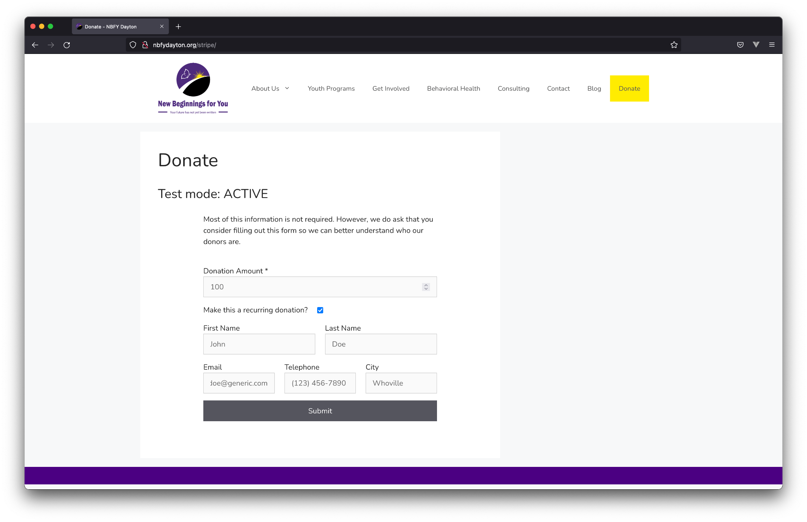

The only required field here is the donation amount, denoted with an asterisk ( * ). The other fields are purely optional, and serve to provide non-profits with basic donor metrics beyond what Stripe collects by default.

In this form, there is also the option to make the pending donation recurring. If a donor chooses to make a recurring donation, Stripe sets up a “subscription” attached to the customer. This subscription starts with a 30 day “free-trial,” and then processes a payment every 30 days thereafter. The subscription starts with a trial as a means of avoiding a double charge for the first payment. Cancellation of this subscription will be reviewed on page 22 of this document.

Clicking the “Submit” button takes the user to the payment form. This form is entirely hosted by Stripe, and cannot be changed. This is an important detail of this particular implementation of Stripe. *All payment data including credit card information is consumed by Stripe, and does not touch the non-profit’s servers. This saves considerable liability in the secure handling of confidential information.*

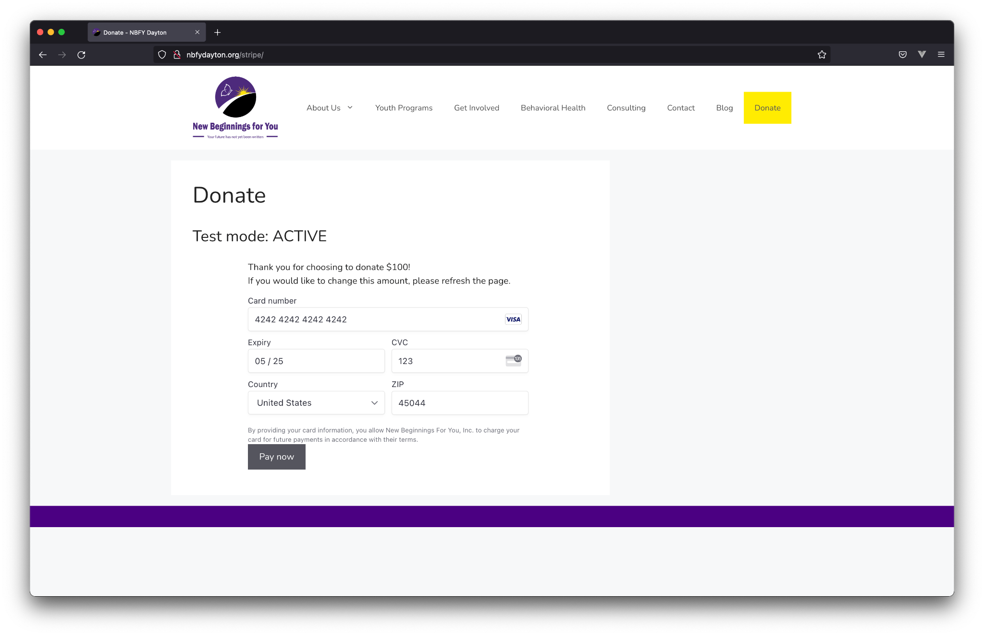

The form displays all of the information required to process a payment. This form will not always look the same. Stripe determines what information is required on a per-transaction basis. Sometimes it may require a billing address, name, etc.

In addition to displaying the payment form, this page displays the chosen donation amount, along with instructions to refresh the page if a change to this amount is desired.

Upon successful payment, the user is redirected to a “Thank you” page. This page is entirely customizable by the non-profit.

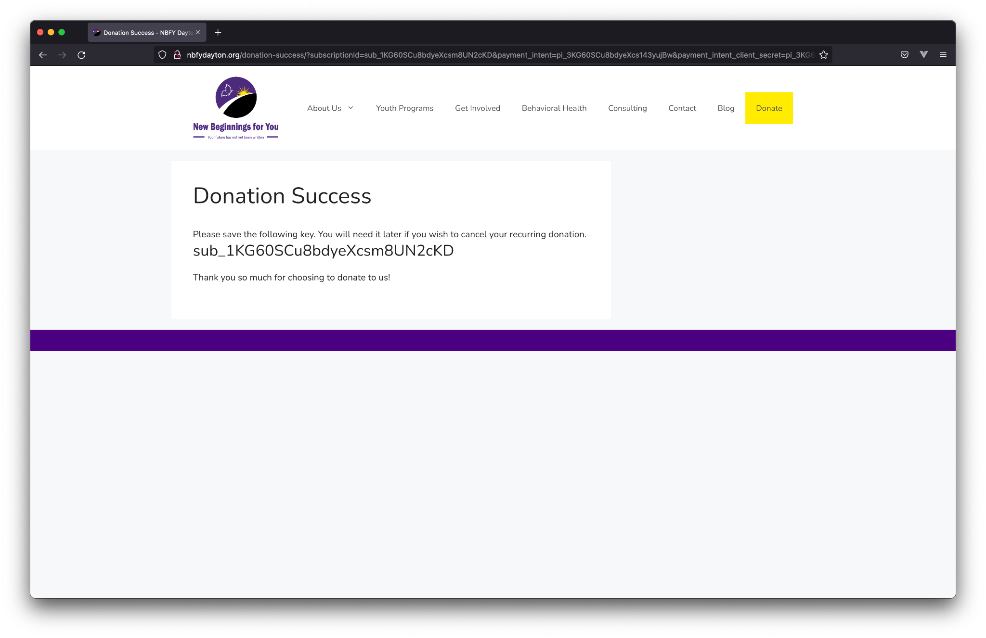

It is important to display the subscription id (sub_1KG60… in the example above), if the user has chosen to make recurring donations. Displaying this id is incredibly simple, and will be reviewed on page 42 of this document.

Finally, a page must be provided to cancel recurring donations. This page is completely customizable by the non-profit, with the form being easy to implement. This will be discussed on page 42.

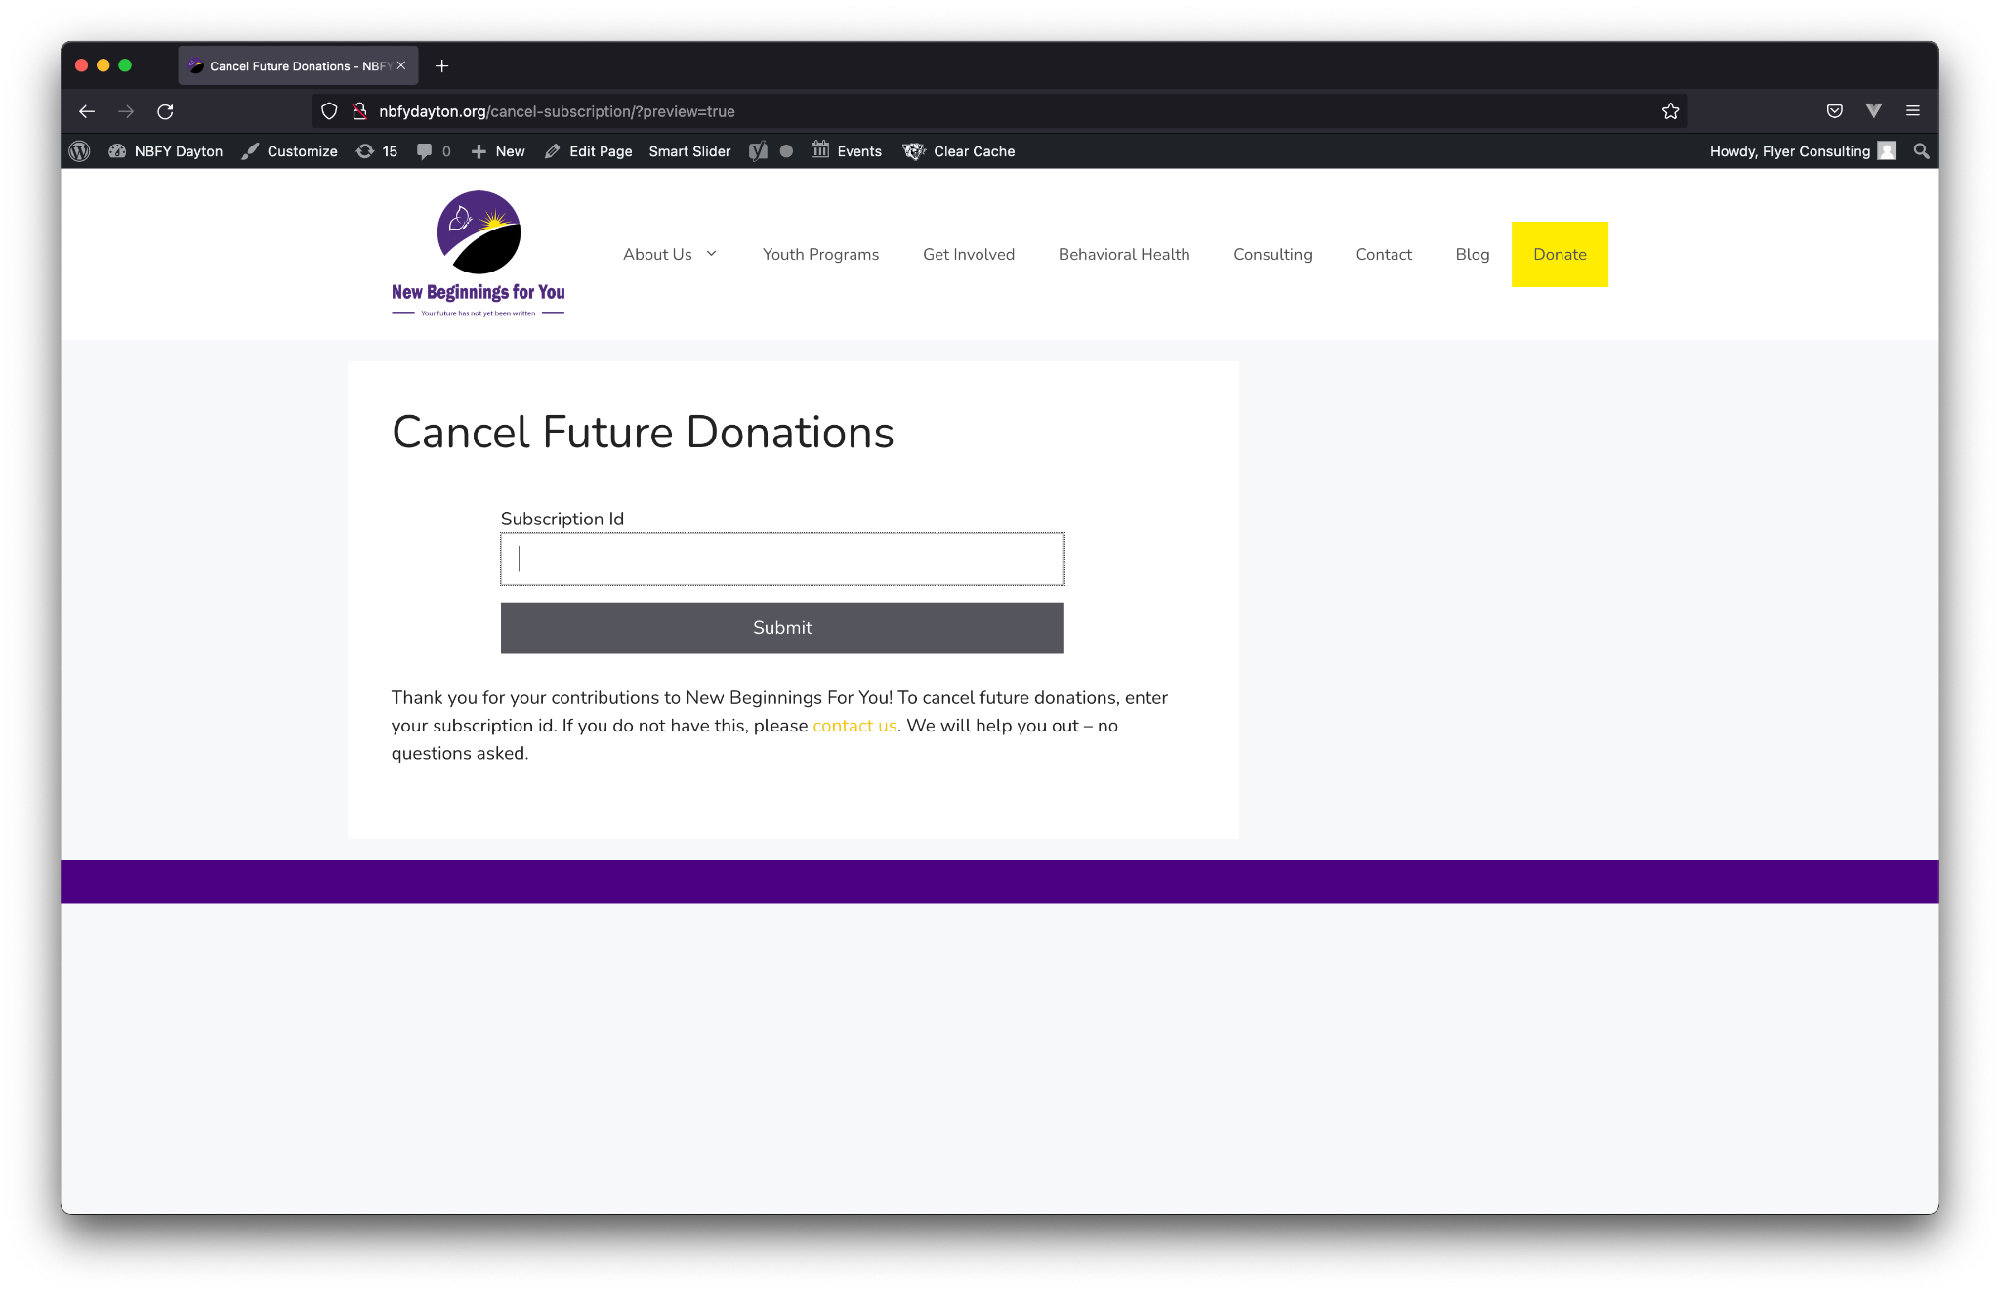

Cancelling future donations will post an end date on the subscription in Stripe’s website, and will stop Stripe from processing future payments.

# Stripe.com

Now, let’s take a look at what data can be gathered from [Stripe’s website](http://stripe.com). Please note, any and all information displayed in screenshots is *not* representative of [New Beginnings For You's](http://nbfydayton.org) income. All data is test data, which is completely separate from “production” data.

### Dashboard

The first page seen after logging into a Stripe account is the dashboard. This dashboard gives quick insights into payments. This doesn’t display donor information, but it does give a quick overview of how much money is coming in and other trends.

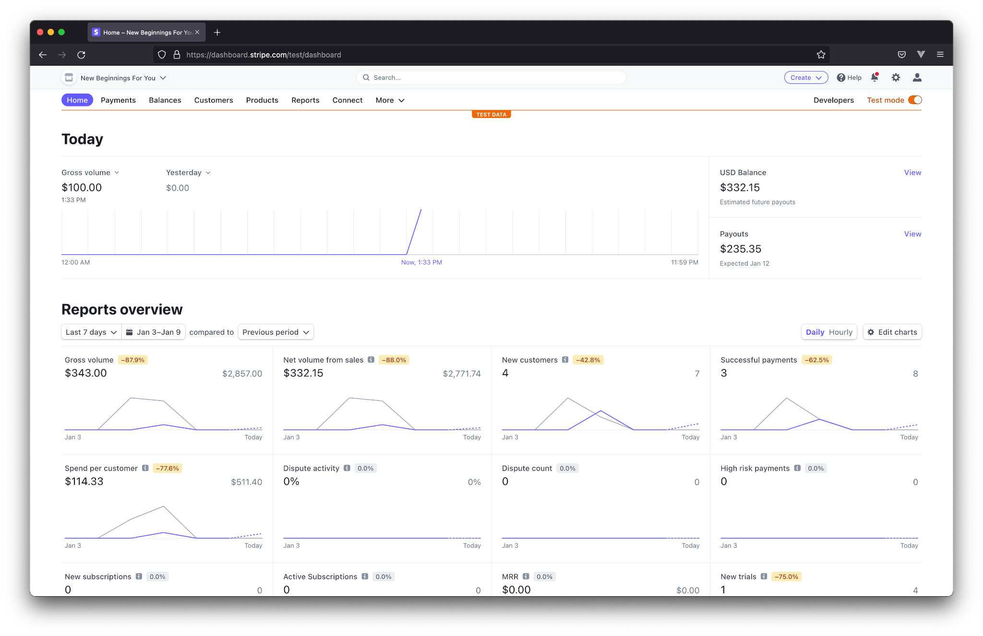

These charts show historical data for two periods - the current period, and the previous. In this case, “Last 7 days” is selected, meaning a “period” is 7 days. The purple line is the current period, and the gray line is the previous. Looking at the “Gross volume” chart, we can see that donations are down 87.9%. Additionally, we see that $343.00 have been collected in the past 7 days, versus $2,857.00 in the prior 7. We can also see that there was an influx in donations in the middle of the prior week. This can reveal valuable information. Was there a promotion going on during this time? Was a new social media strategy attempted? Did the non-profit receive attention in the media? Asking questions such as these can provide a direct indication of how well a new initiative performed.

### Payments

Next, let’s move to the “Payments” tab.

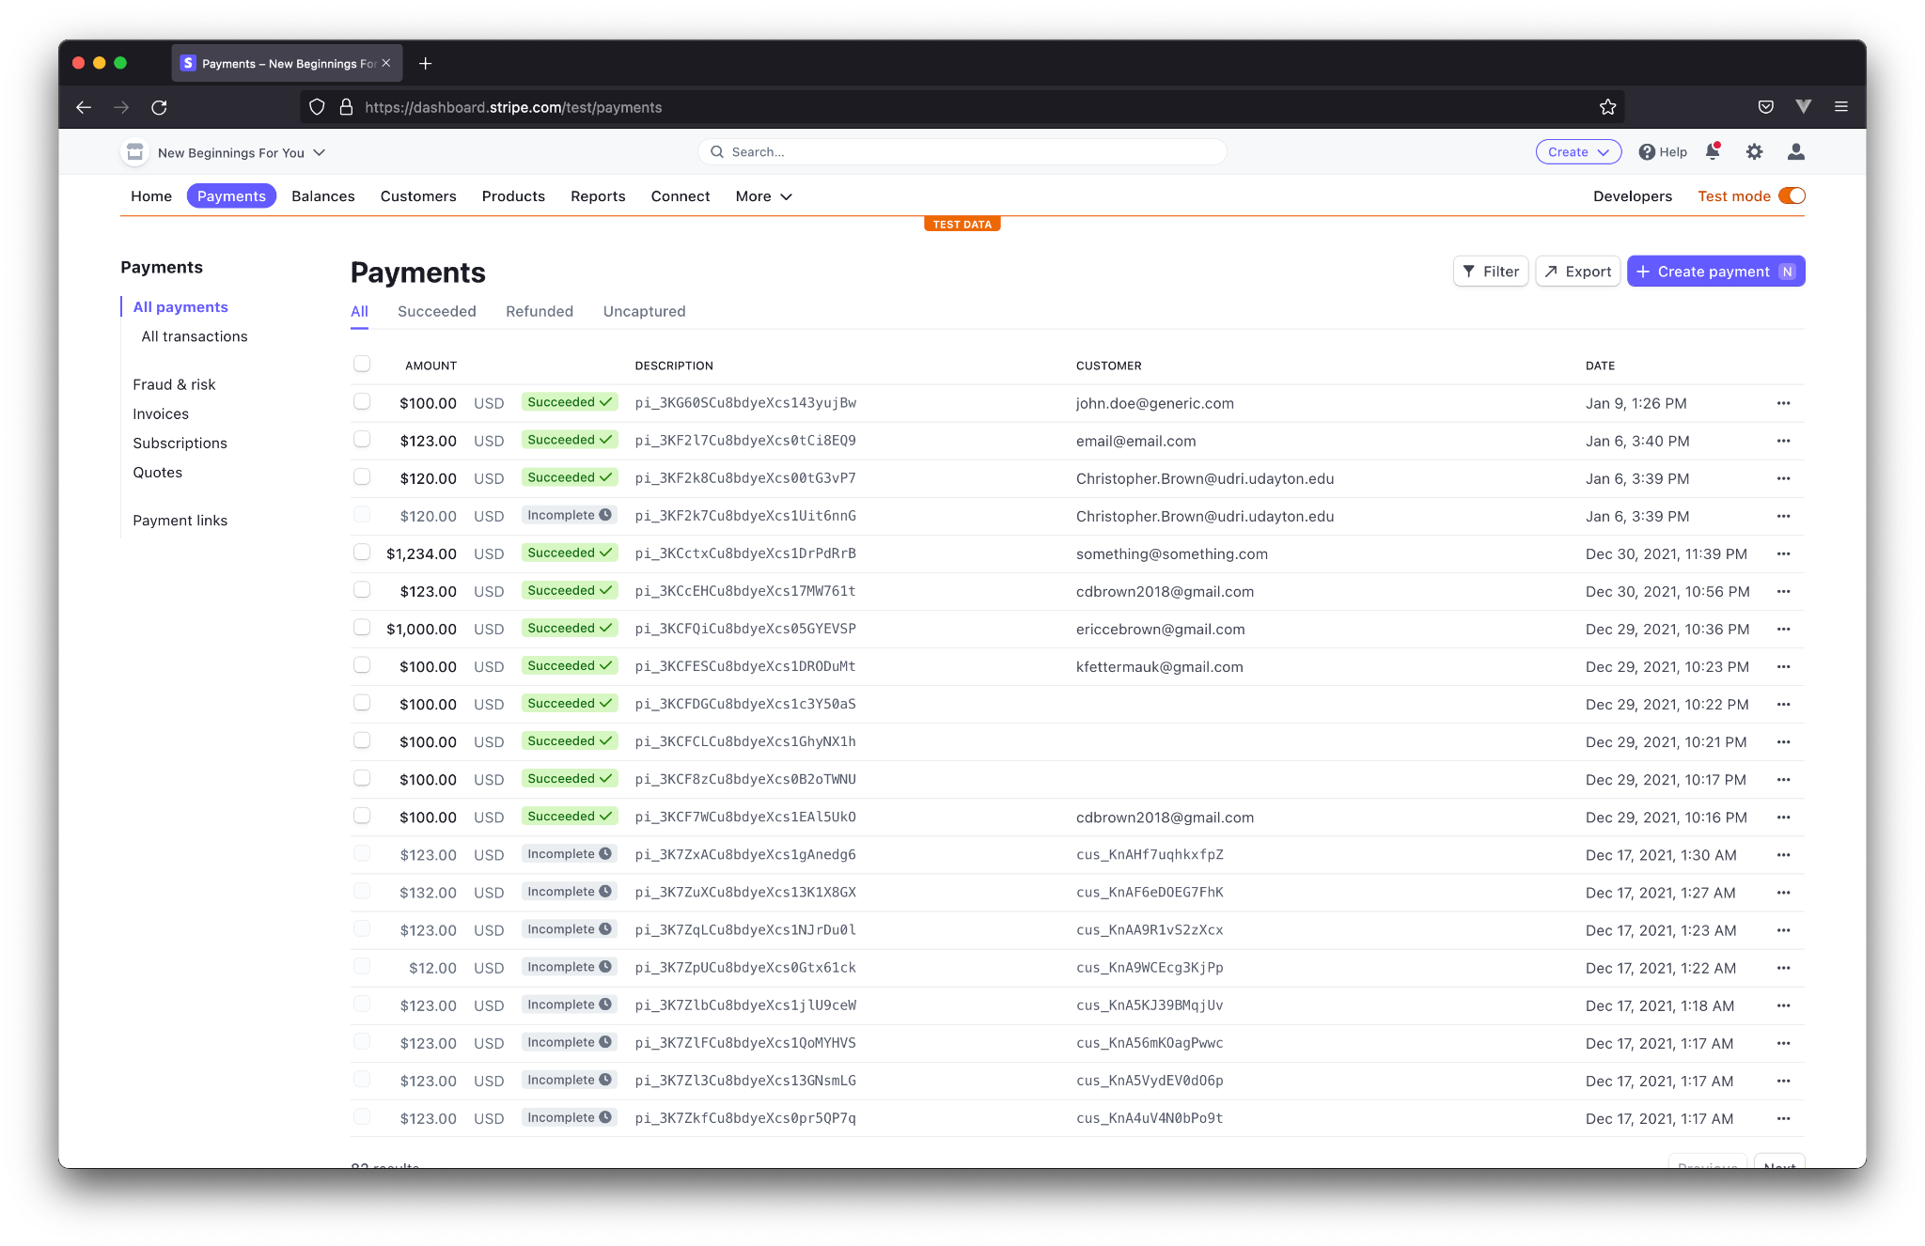

This page is relatively self-explanatory. It displays all payments made, whether successful or incomplete. It displays the amount donated, the currency type, status, the payment id, the customer’s email address, and the date of the donation.

Clicking on a payment reveals a wealth of information.

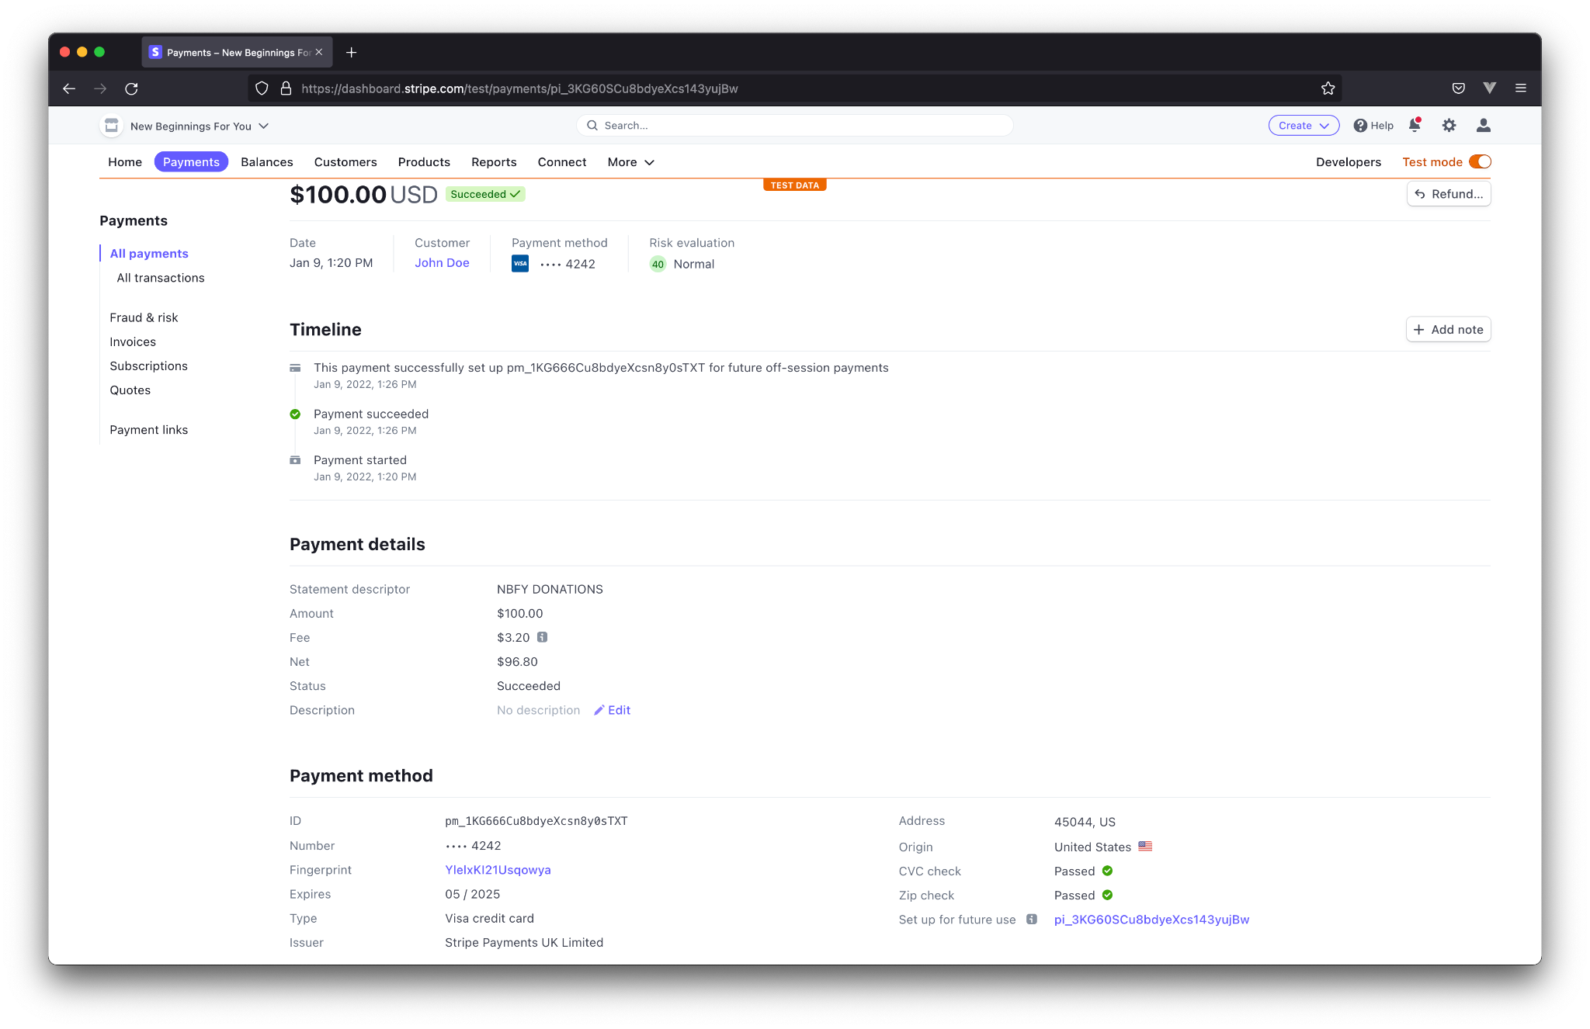

First, we see how much the donor chose to donate. This is followed with basic information such as the date, the customer’s name, the payment information, and “risk evaluation.” Risk evaluation is an indicator of fraud. Stripe automatically checks for signs of fraud, and will provide detailed information if it detects anything suspicious.

Following this, we see a timeline of the donation process. We can see that the “intent to donate” was submitted at 1:20 PM. This corresponds with the user clicking “submit” on the first form discussed in the previous section.

At 1:26, the user successfully made the payment, clicking “Pay now” on the Stripe donation form. This particular user also chose to make a recurring payment. The timeline reflects this, indicating that the payment method was saved for “off-session” payments. Off-session payments are payments where the customer doesn’t have to be involved with the transaction.

The next important section is the “Risk insights” section. This expands on Stripe’s analysis of potential fraud.

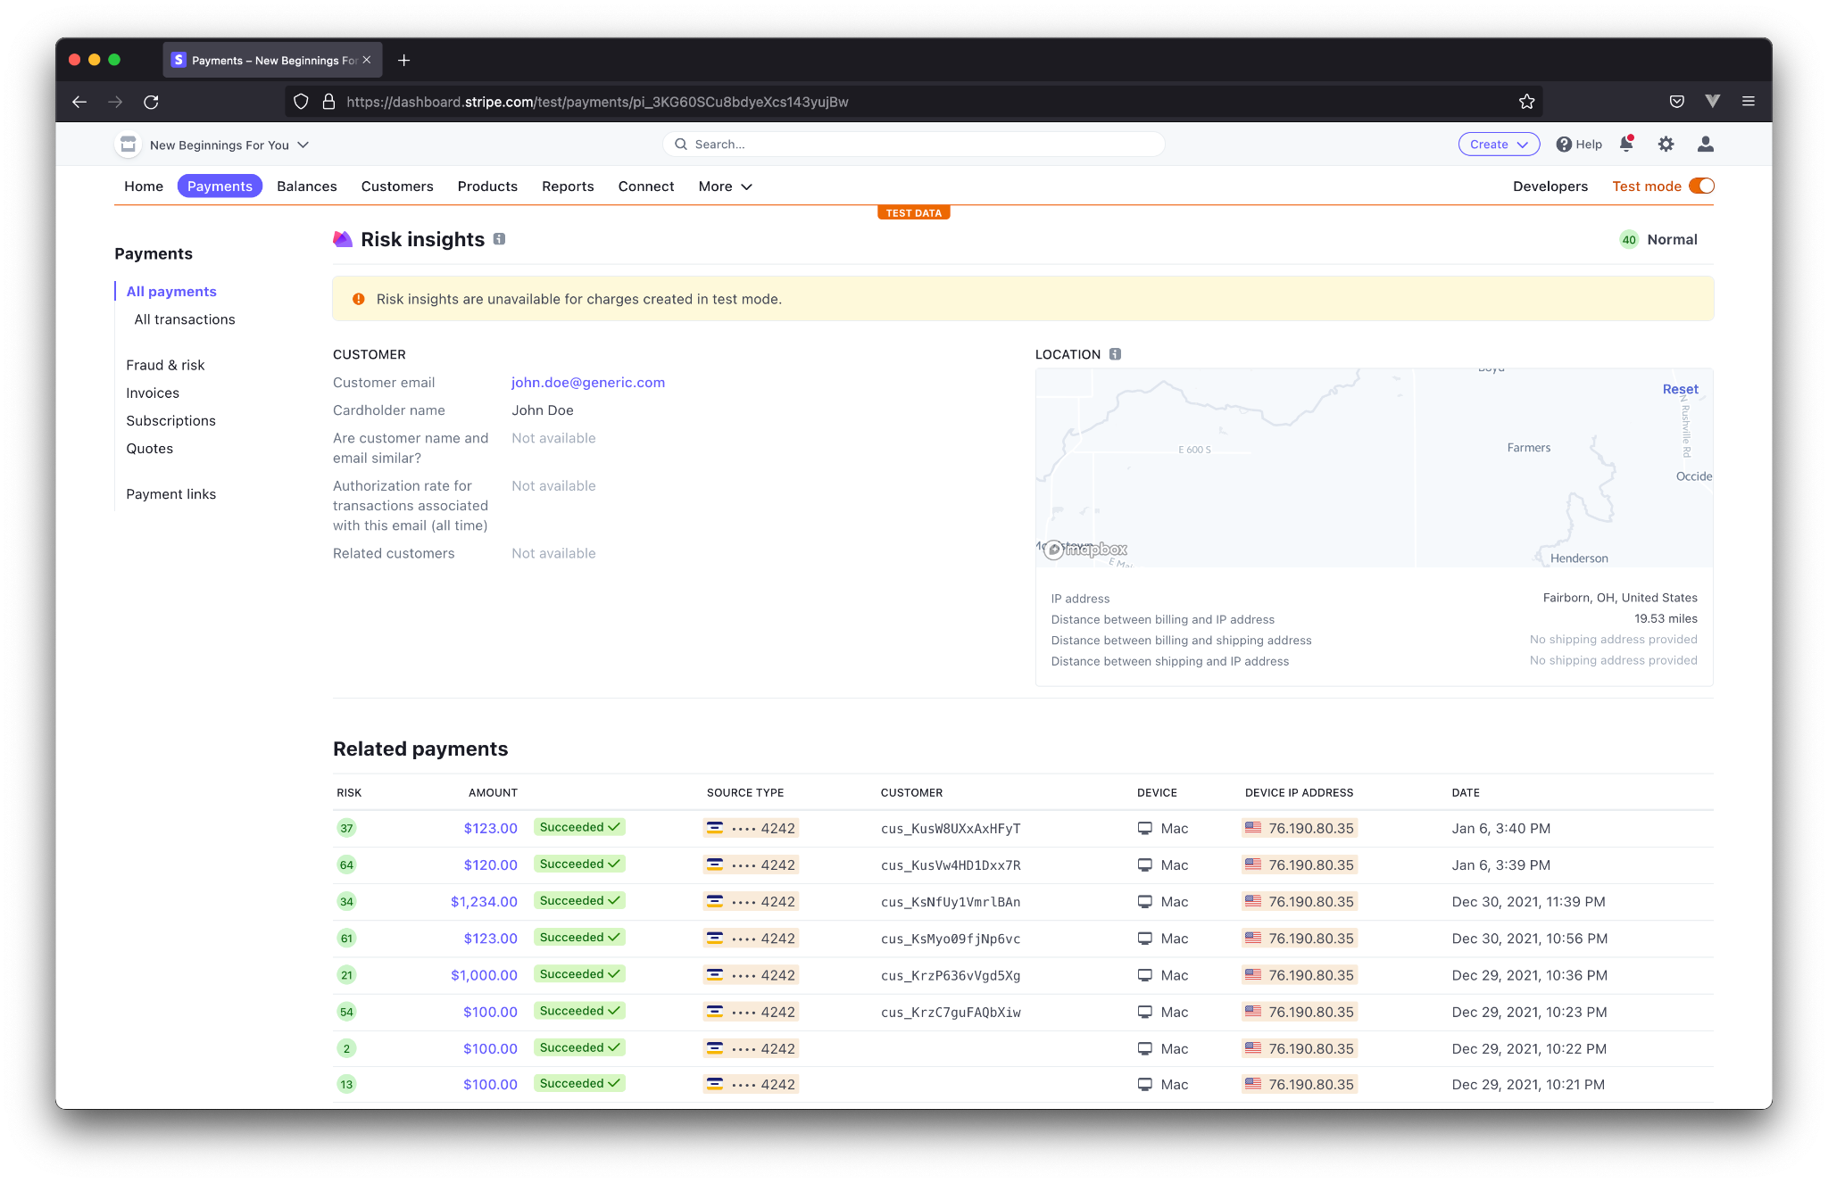

We see basic info such as the email and cardholder name. If Stripe were in “live mode,” it would also display whether or not the customer’s name and email are similar, the rate of successful payments associated with the provided email with other Stripe accounts, and any related customers. Every mismatch in this information is an indication of fraud.

Stripe also takes a look at the user’s location relative to the card’s registration. Every computer connected to the internet broadcasts its public IP address. Among other things, this address can be used to determine the user’s approximate location. In this case, we can see that the payment was made in Fairborn, OH - about 20 miles from the card’s zip code, 45044. If the distance is sufficiently far, this could be a great indication of fraud.

Finally, we see the “Related payments.” These aren’t necessarily payments made by the same customer. They are, however, payments that are linked in some way. In this case, the payments were made from the same credit card, and same IP Address. This could be a couple making separate donations, or it could be the same person. Either way, it gives an indication as to the household’s donation habits.

### Subscriptions

The next important section is the subscriptions. The initial page displays a list of all active subscriptions, or recurring donations.

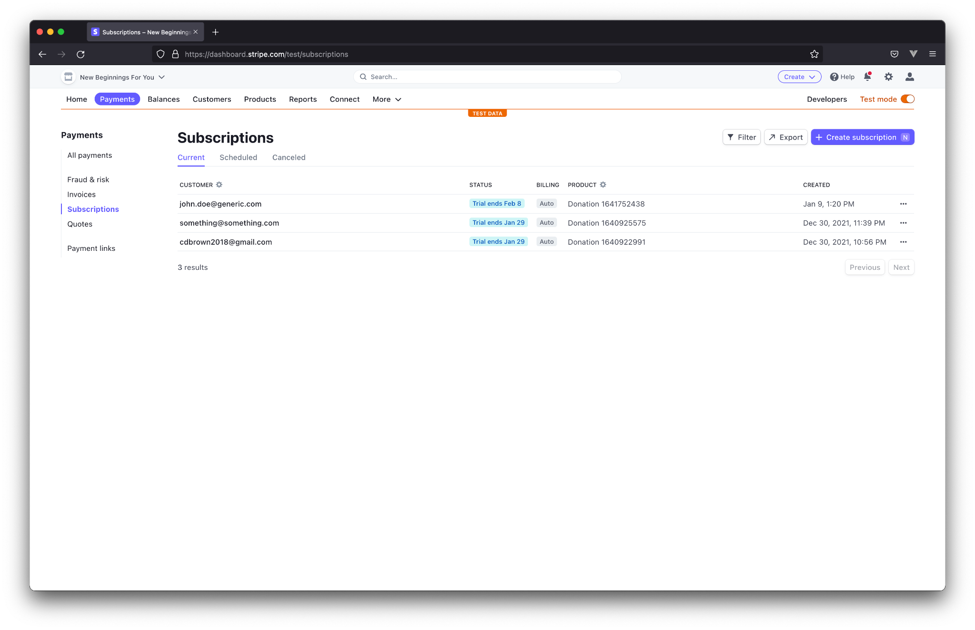

Here, we see a list of 3 customers that have chosen to make recurring donations. Clicking on a subscription again pulls up relevant information.

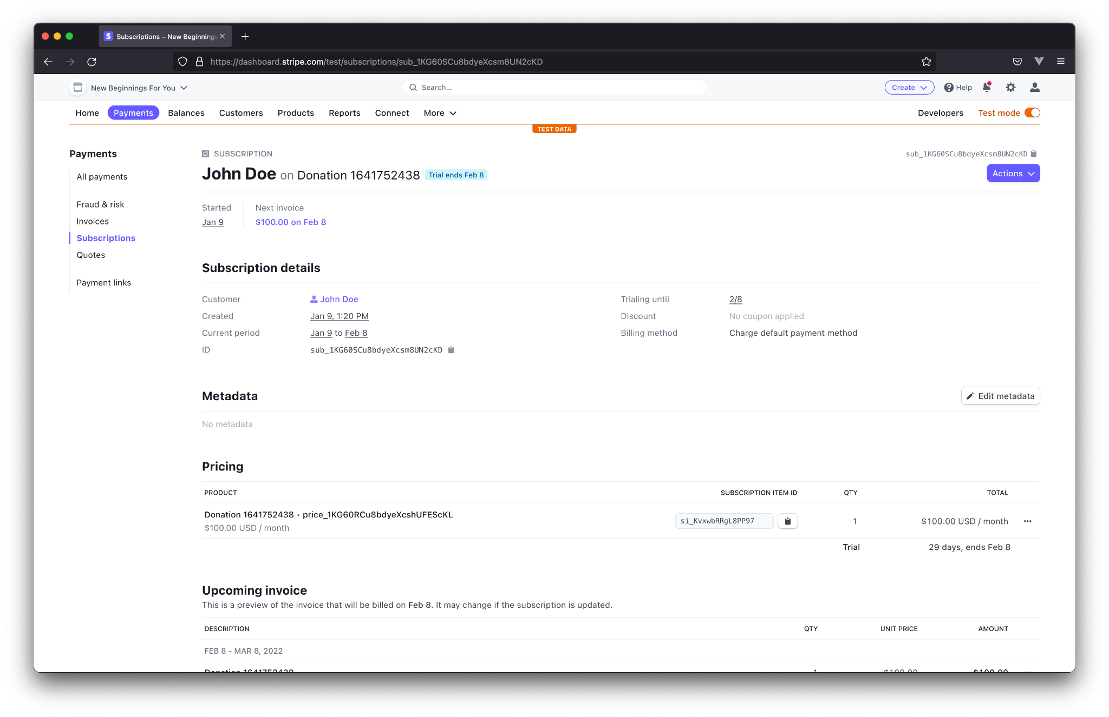

Here, we can see the name of the customer, when the subscription started, when the next payment will be processed, and how much that donation will be.

Below this we see slightly more detailed information about the subscription. A link to the customer is displayed along with the trial period, and the payment method.

The pricing section simply displays how much the donation is worth.

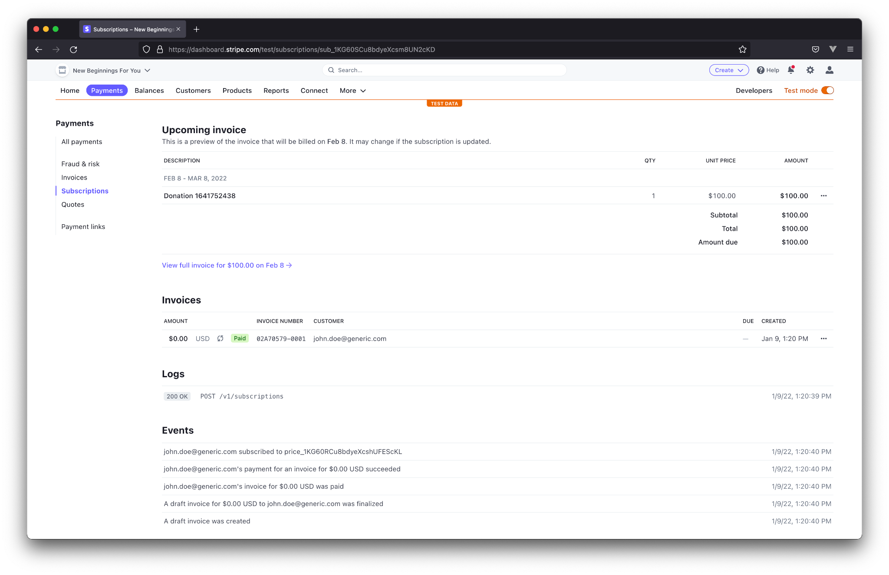

Beyond this, we see information about the next invoice, prior invoices, and events corresponding to payments. Please note, the invoice amount in this example displays $0.00 as a result of the “free-trial” discussed earlier. The first payment was processed as a separate payment by Stripe.

### Balances

The “Balances” tab displays how much money is in the Stripe account, how much is currently being transferred to the non-profit’s registered bank account, and projected payout from pending transactions.

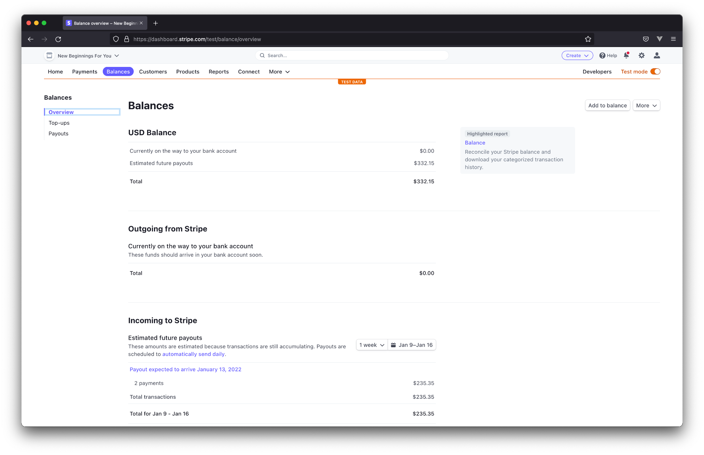

### Customers

The “Customers” tab displays information about customers. The initial page displays a list of all known customers.

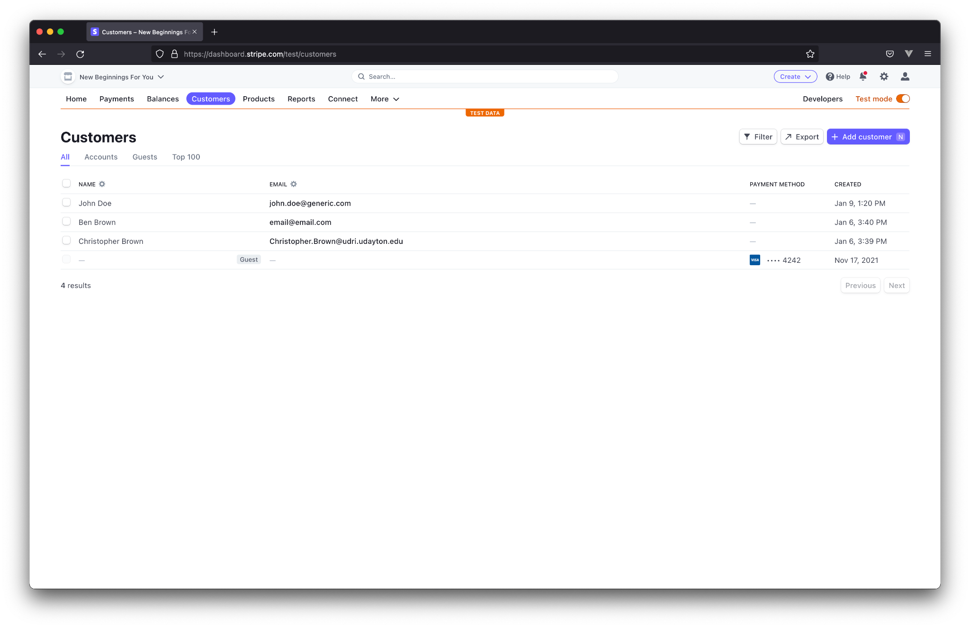

Clicking on a customer reveals incredibly detailed information pertaining to an individual customer.

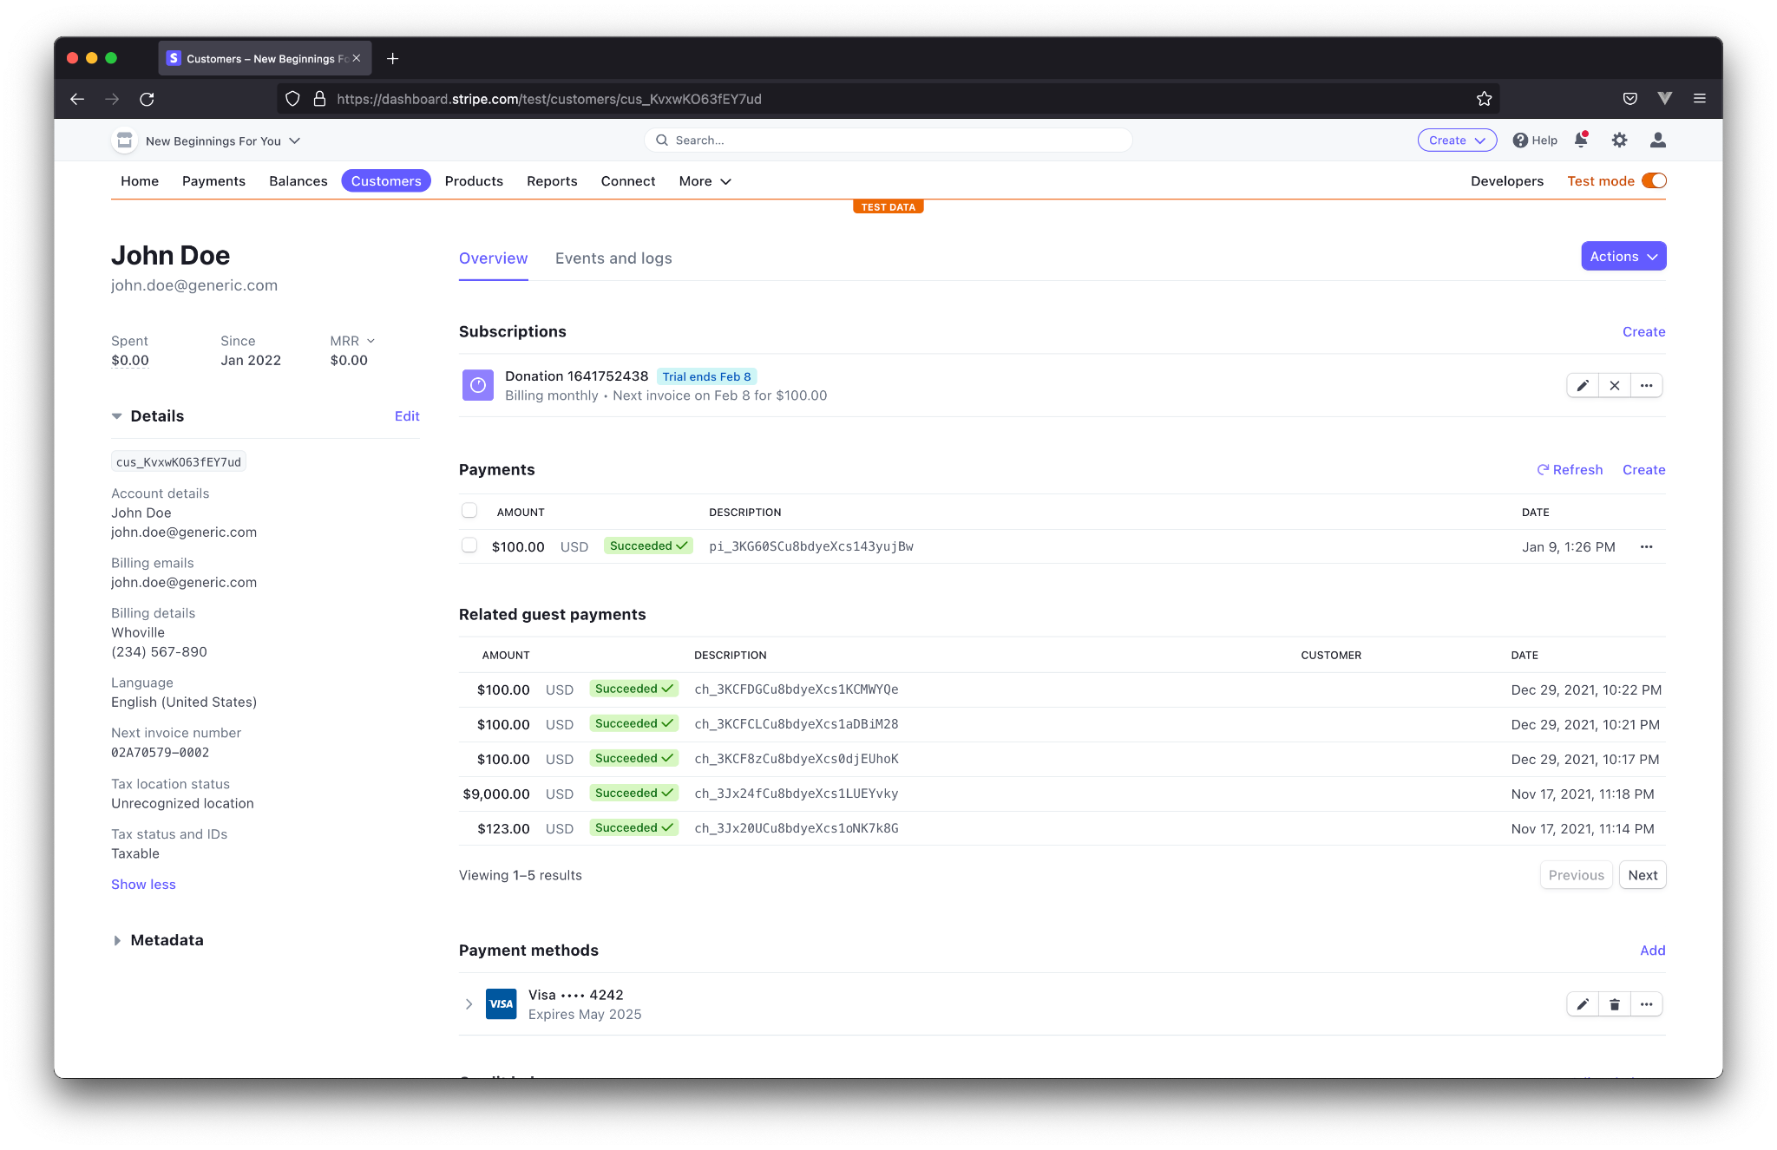

On the side, the customer’s name, email, address, phone number, language, tax location, and tax status are displayed. In the middle, we can see the customer’s existing subscription, previous payments, related payments, and the customer’s registered payment methods. Of course, clicking on any of these records will take you to the applicable pages previously discussed.

### Reports

Finally, we come to the “Reports” section. This displays everything related to money. Unfortunately, most of this data is not available in test mode, so information can not be provided by Flyer Consulting. We encourage you to look through the various reports after several months of donations to find reports relevant to you.

A few reports however, *are* available in test mode. The first of these is the “Financial reports.”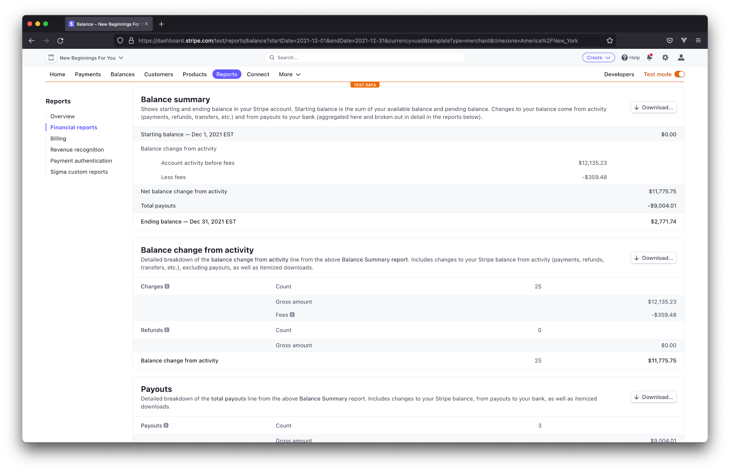

This report shows the gross income, followed by the net income, after Stripe’s fees have been taken out.

The “Billing” section displays graphs similar to the graphs shown on the main dashboard.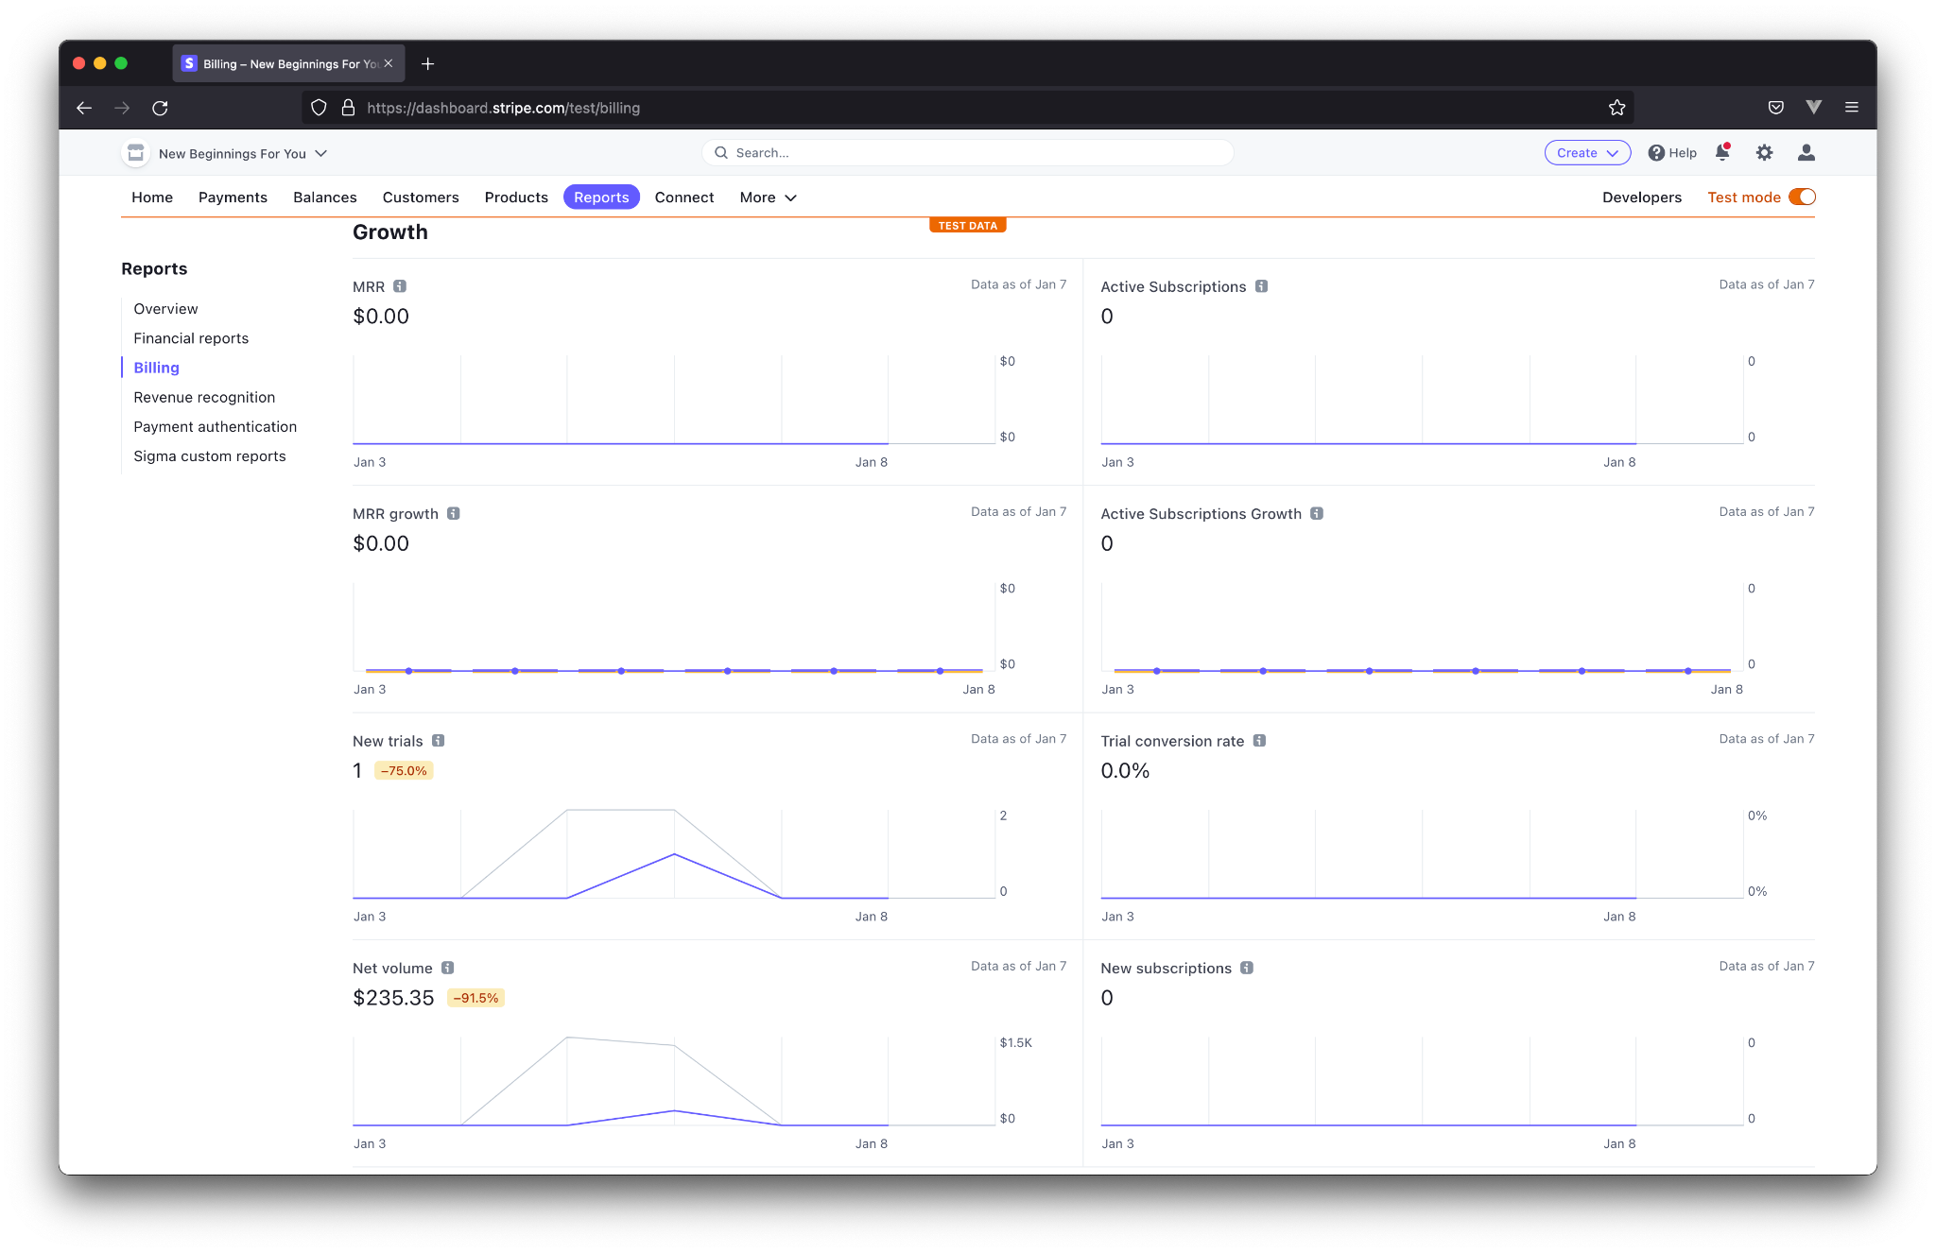

Here we can see metrics corresponding to the organization’s growth. It is important to note here, the “Active subscriptions” graphs display subscriptions that are *not* currently in a trial period, meaning at least one payment has been processed outside of the initial 30-day trials. Trials are displayed in the “New trials” graph, which will eventually move to the “New subscriptions” and “Active Subscriptions” charts. These graphs function similarly to those shown on the dashboard, with the purple line showing the current period’s trends versus the previous period’s trend, shown with the gray line.

# 

# Handling Donor Requests

In the life cycle of donations, it is inevitable that a donor will contact your non-profit for support. Below are instructions for handling anticipated requests.

### Cancelling recurring donations

While the subscription id is provided to the donor to cancel their subscription, it is conceivable that the donor will misplace this id. In this case, the user may contact your organization to assist them in cancelling their donation. Luckily, this is a simple process.

The first step is to ask for the donor’s email address. Once provided with an address, search for it in the search bar at the top of the page.

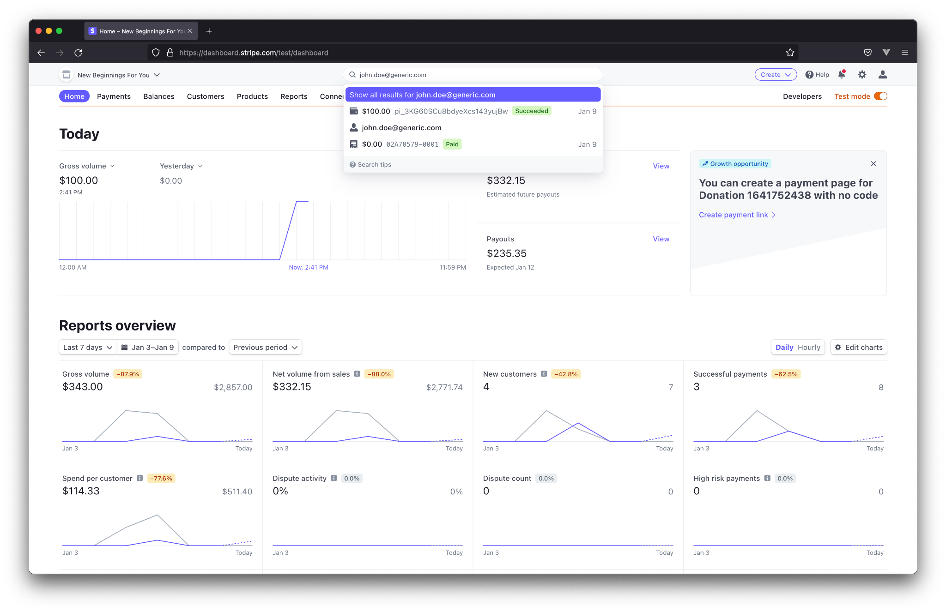

Click on the entry with the silhouette of a person, followed by the email.

This will take you to the customer’s page.



Here, you will see the customer’s subscription. Confirm the amount of the donation - displayed in the subtext of the subscription information ($100.00 in this case), and the last 4 of the payment method (4242 in this case). Once we have confirmed this is the correct customer, and the correct subscription, cancel it with the ‘X’ button displayed to the right of the subscription.

### Refunding a Donation

It may happen that a donor wants to cancel their donation. Fortunately, this is an even simpler process than cancelling subscriptions.

First, ask for the last 4 digits of the credit card used to make the payment. Search for the last 4 in the search box at the top of the website. Click on the most recent corresponding payment.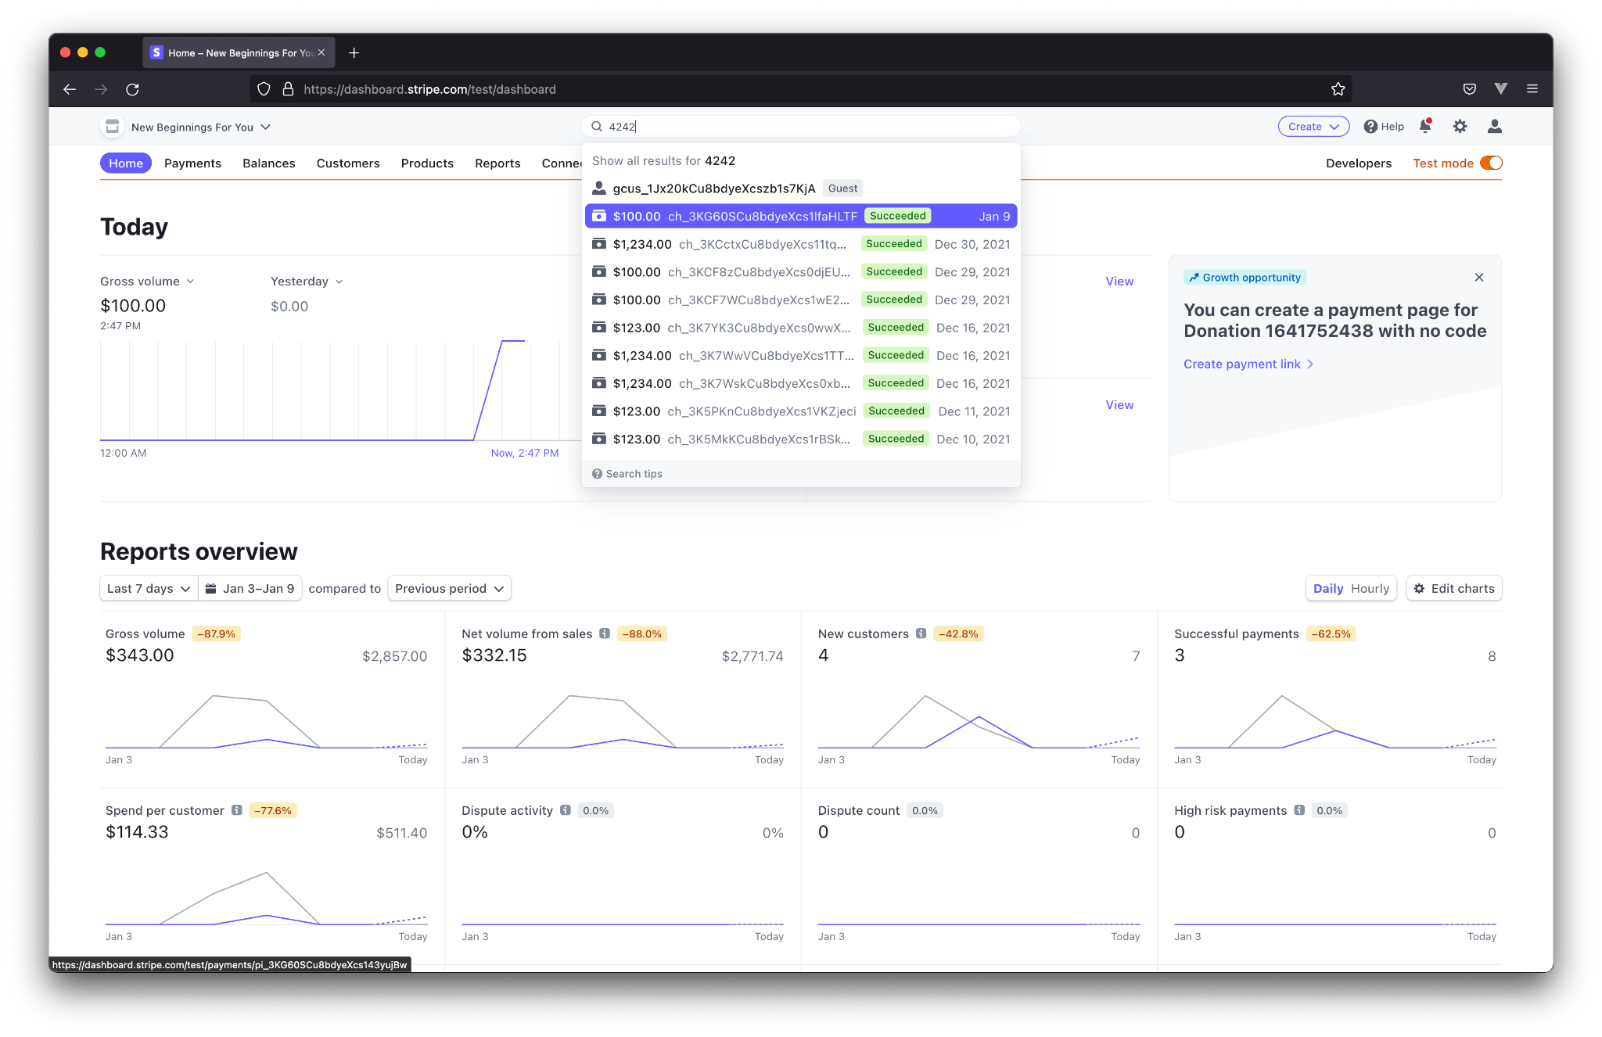

This takes us to the page with information pertaining to the payment.

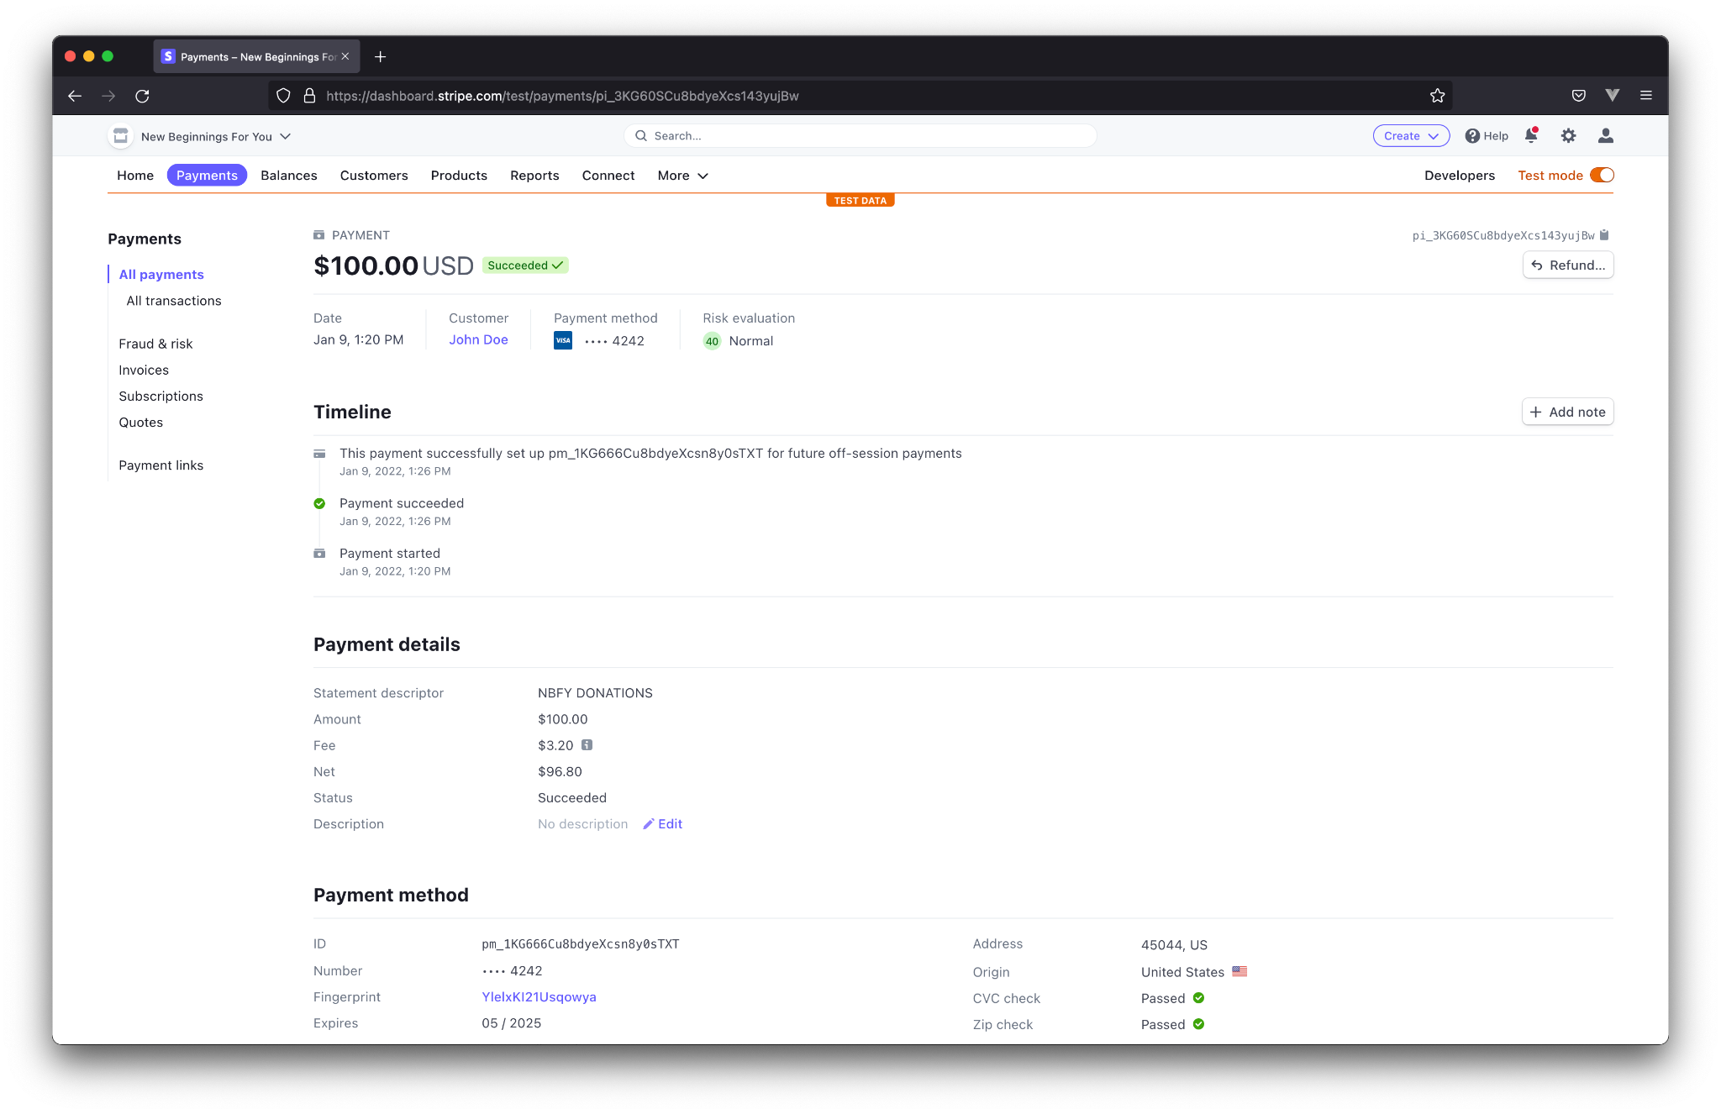

Click the “Refund…” button in the upper right corner.

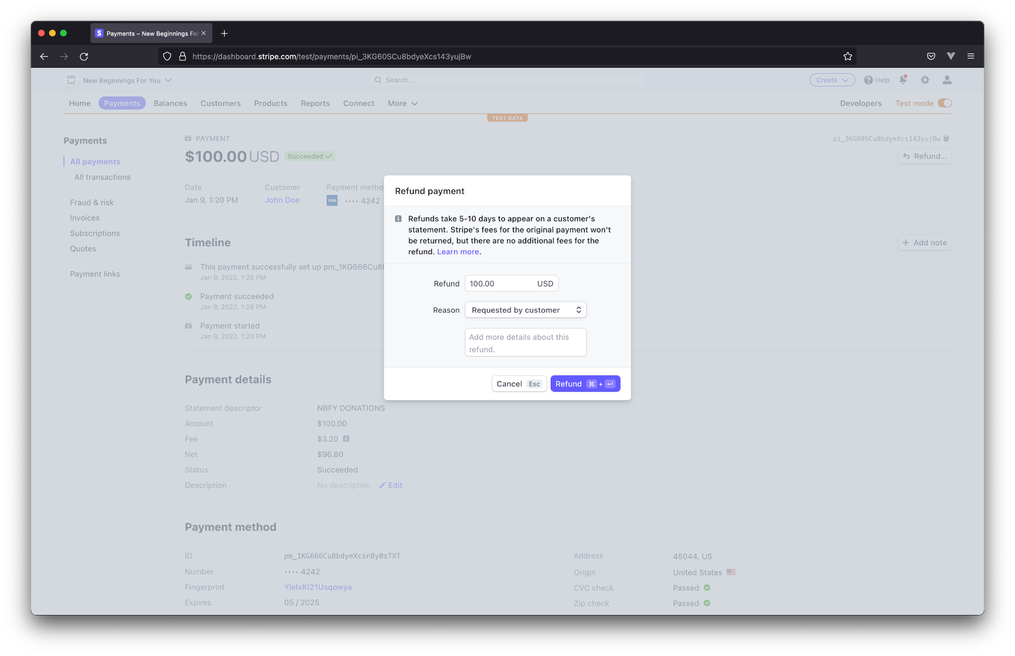

Select a reason, and finally click “Refund” in the lower right corner.

If successful, the payment status will change from “Successful” to “Refunded.”

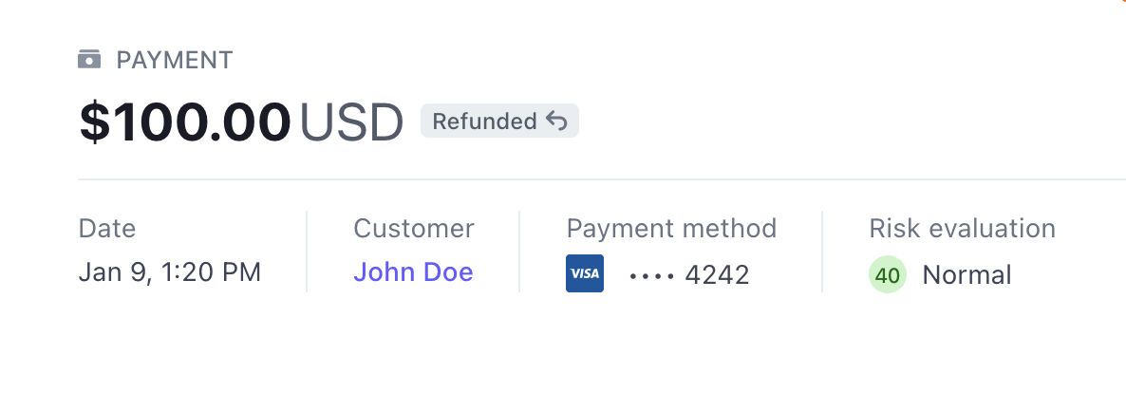

### Right to be forgotten

A recent topic in the public’s attention is the “right to be forgotten.” Under GDPR laws, which apply to all European citizens, even if they reside in the US, an individual has the right to request all data be purged from your website. The US is also working on implementing its own laws, colloquially called the “right to be forgotten.”

If a donor requests to have their data deleted, the process is again simple. Ask for an identifying piece of information. Last 4 on the credit card is the most specific, followed by email, and finally the customer’s name. The customer’s name is the least preferred method because two people can have the same name. Regardless, search for the provided information, and click the entry with a silhouette.

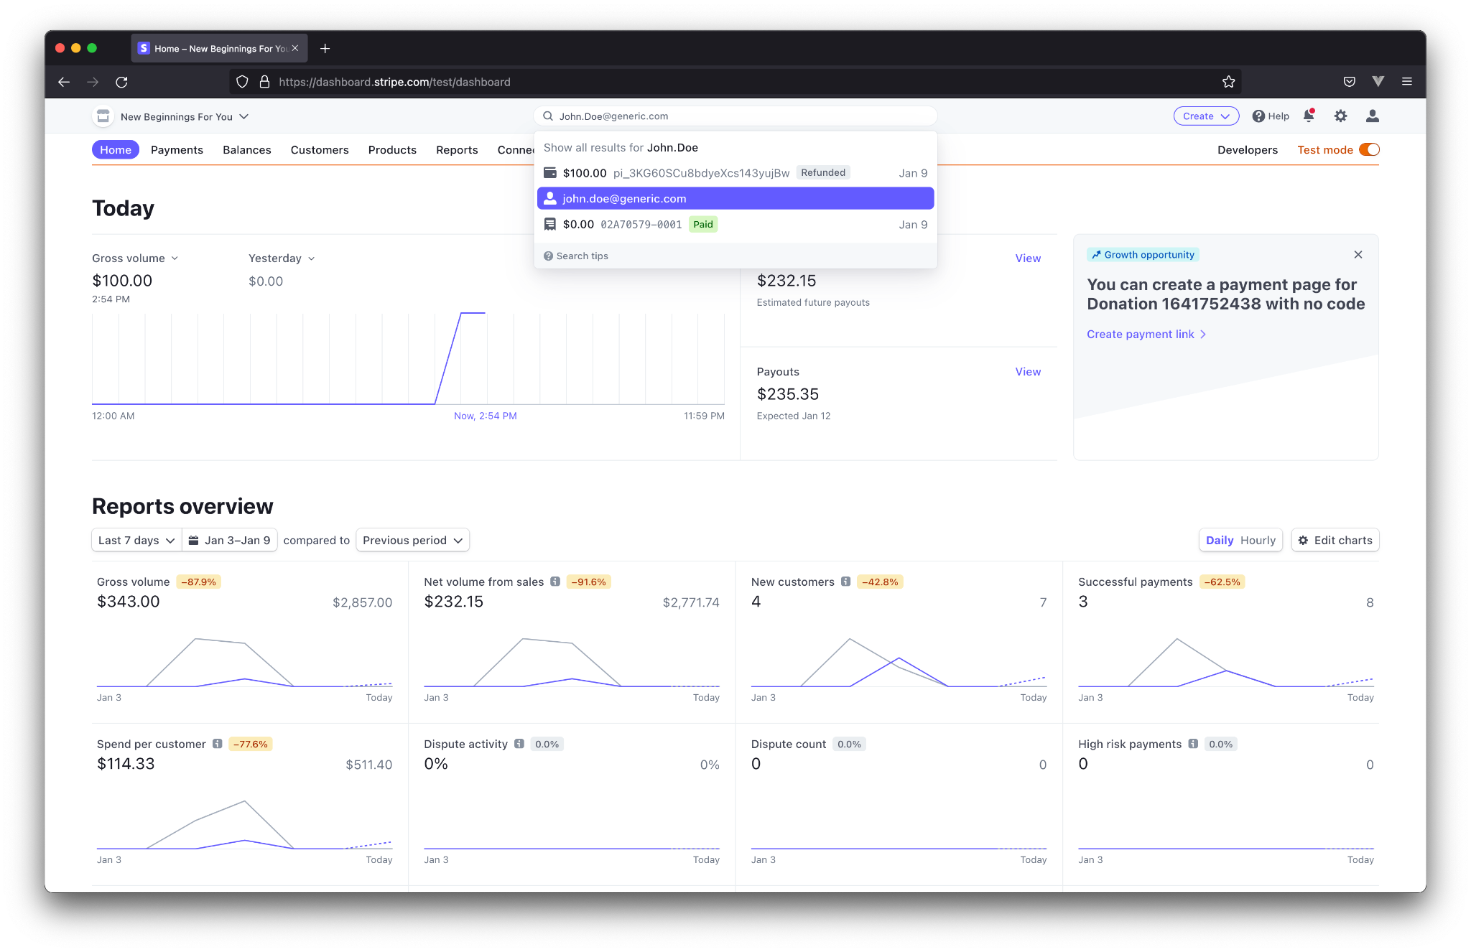

Click Actions > Delete customer

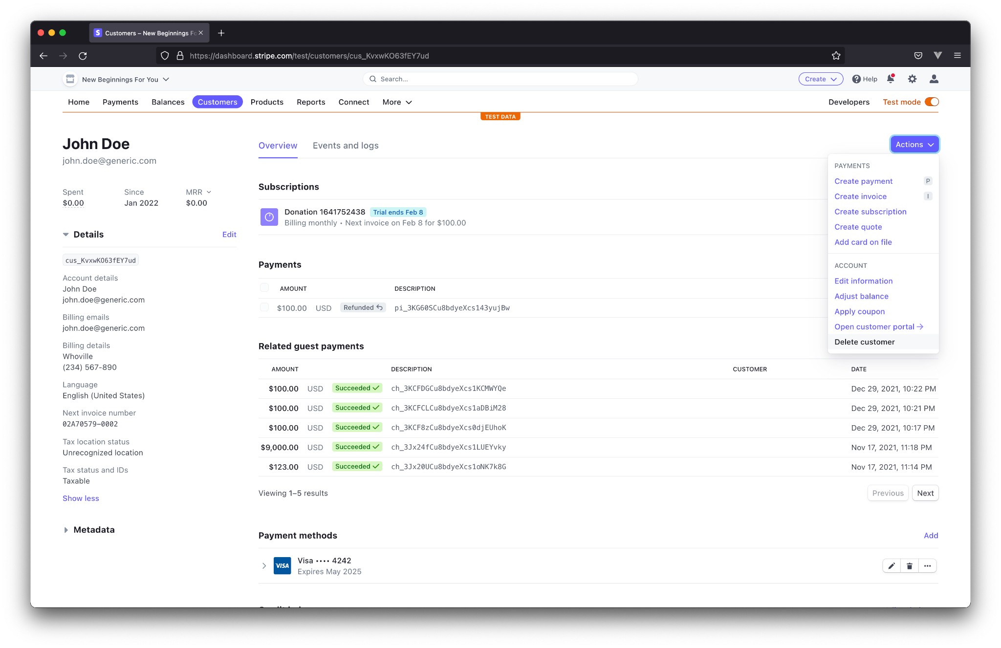

Finally, click the red “Delete customer” button in the dialog.

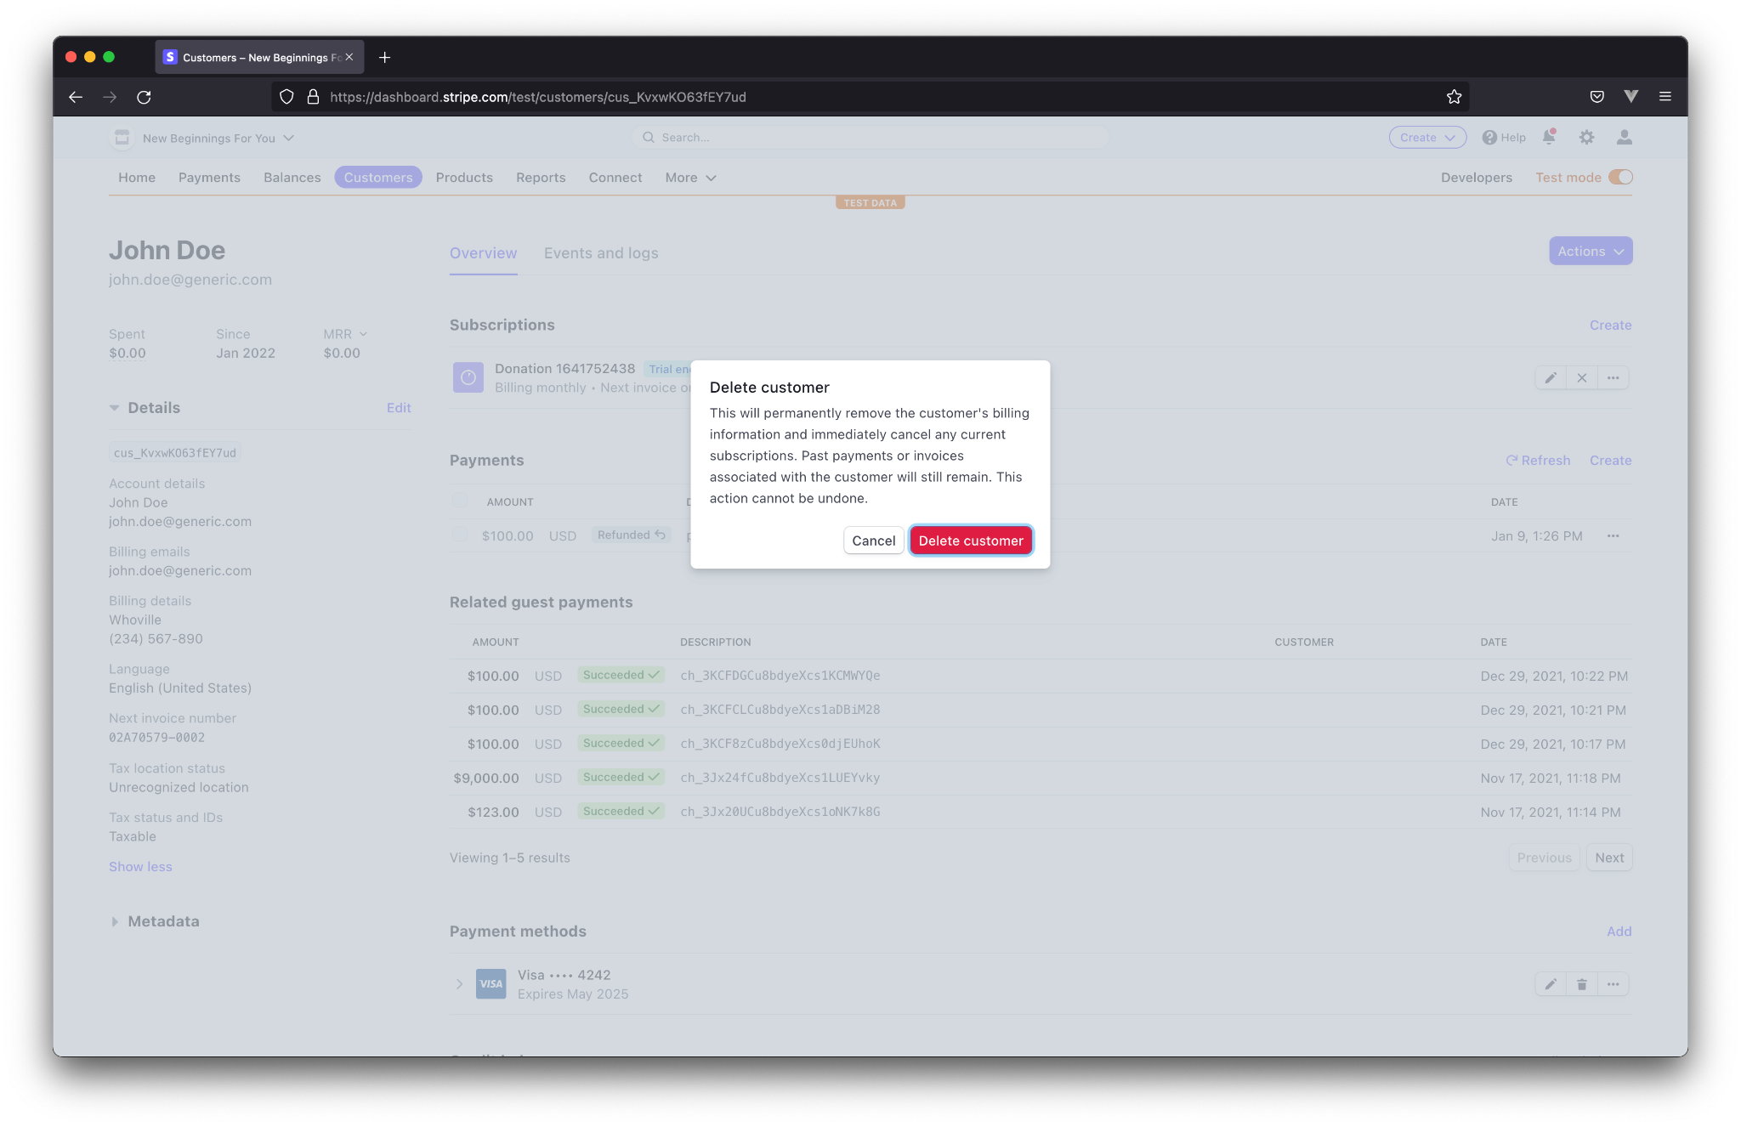

If successful, the customer will no longer appear in the list of customers.

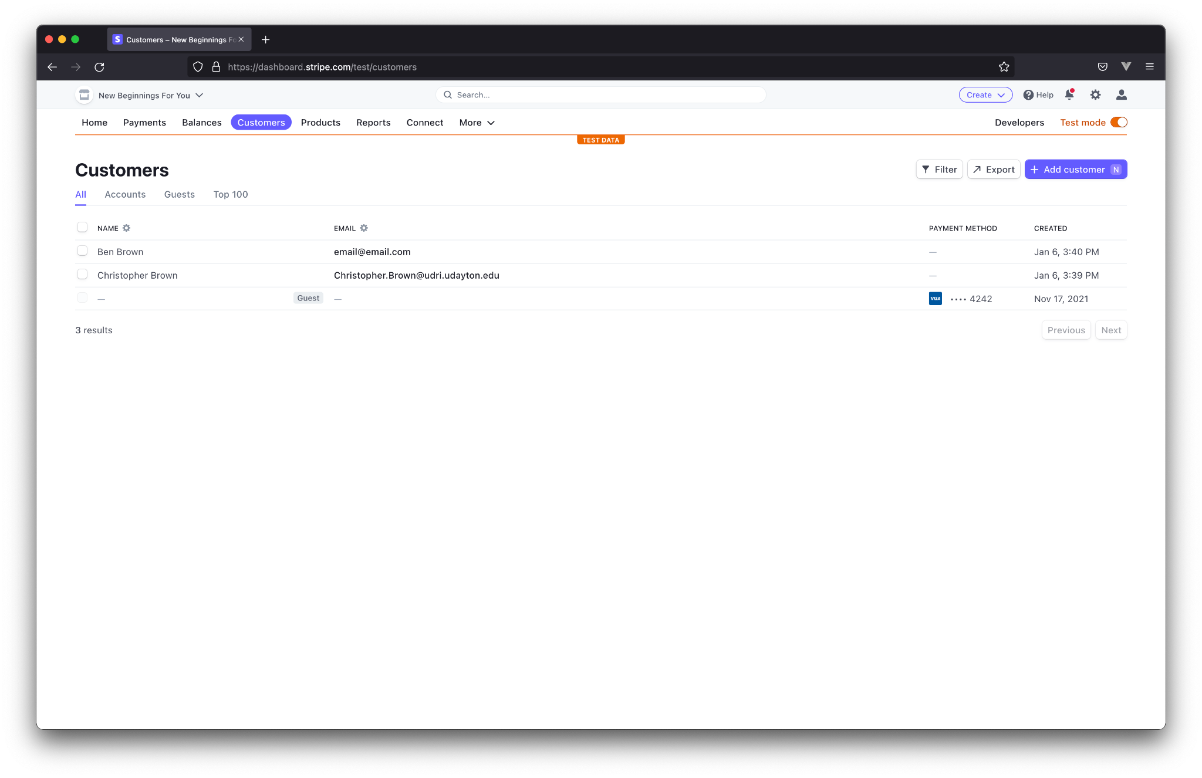

# Plugin Configuration

Finally, let’s discuss the configuration of the Stripe plugin. This plugin is designed for, and will only work with WordPress websites.

The first concept we will discuss is the “shortcode.” Shortcodes are a common item in WordPress websites. Essentially, they allow us to inject pre-configured layouts into our pages. A short code is formatted like “[shortcode_name].” Flyer Consulting’s Stripe plugin has three shortcodes, each of which will be discussed with their respective pages.

### Installation

Installation of the plugin is simple. Login to your website’s administrative page. This is typically at a URL such as *www.example.com/wp-admin.*

On the left hand side, select “Plugins.”

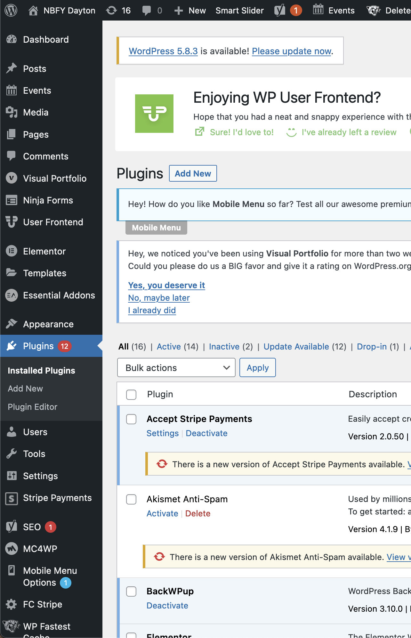

Select “Add New” under the expanded links, and then select “Upload Plugin” at the top of the page.

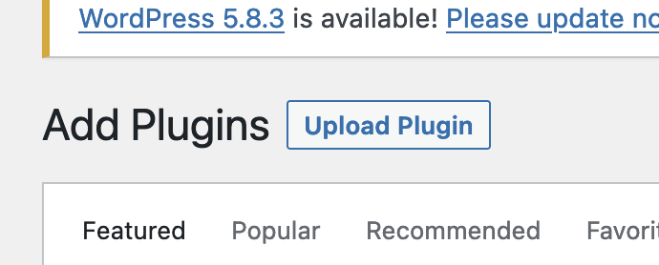

Next, click “Browse”

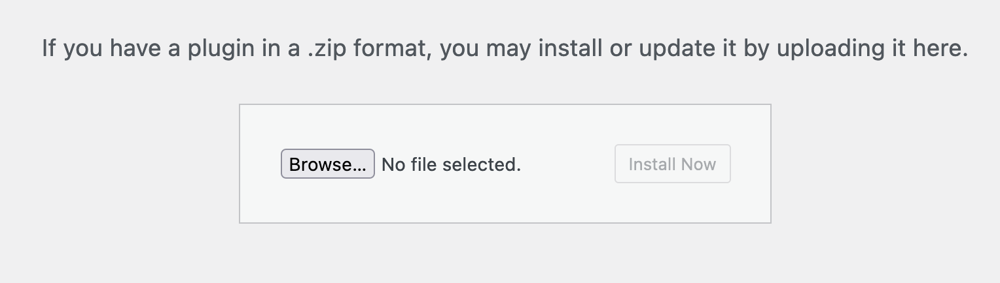

Now, look for the provided *zip* file on your system. It will be named something similar to “fc-stripe.zip”

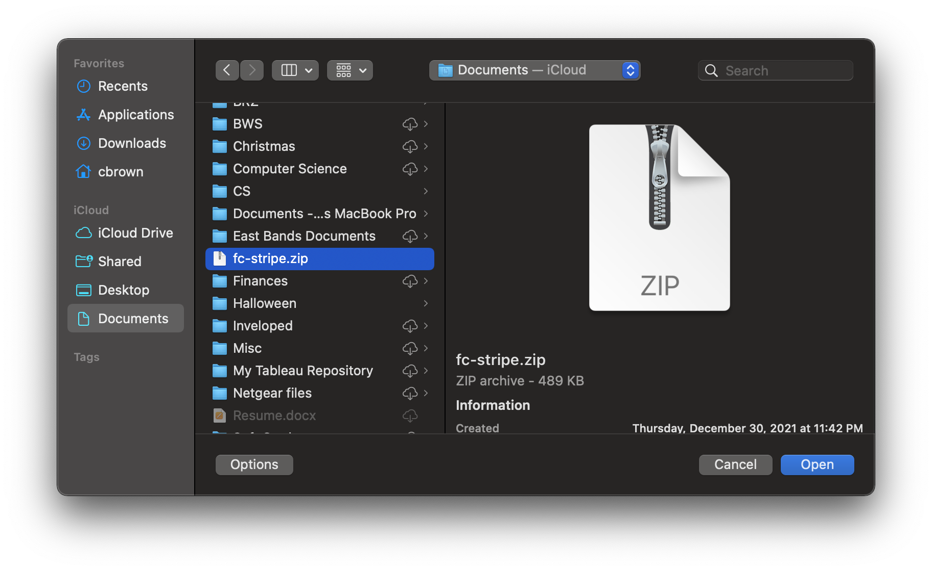

Select “Open.” Please note that this window will look different on Windows machines.

Next, select “Install Now.”

Under “Installed Plugins,” from the left hand menu, look for “FC Stripe Plugin,” and make sure that it is activated. If not, click “Activate.”



Congratulations! The plugin is installed. Now let’s perform the basic configuration

### Basic Configuration

On the left-hand menu, look for and click “FC Stripe.”

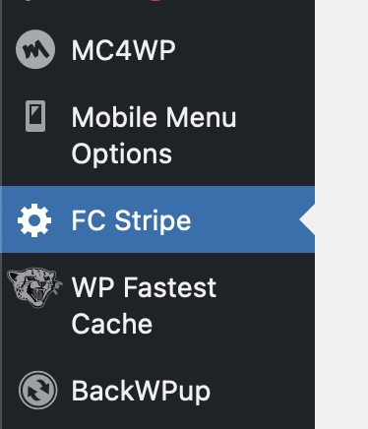

This will take you to a page that looks like this:

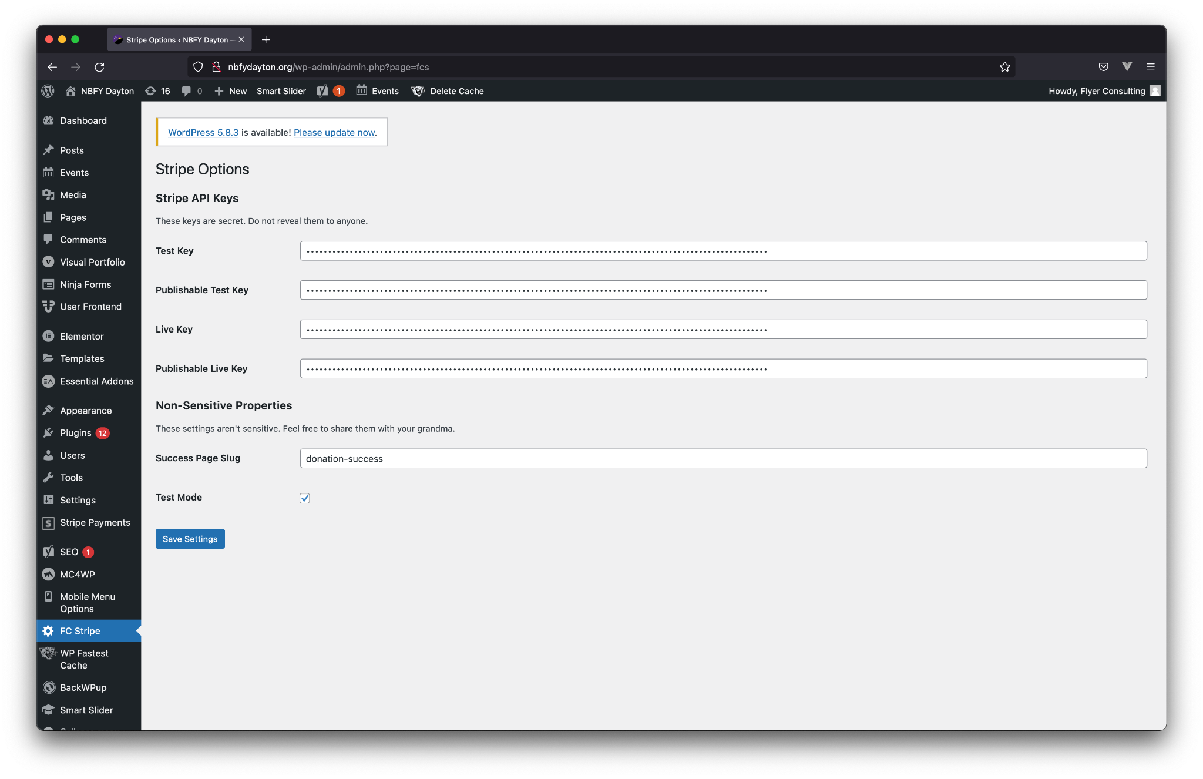

This contains the basic settings for your plugin.

The values under “Stripe API Keys” are what allow the website to communicate with Stripe’s services, and **must be kept secret.** Do **not** share these with anybody else. These keys can be found on Stripe’s website. Select “Developers” in the upper right hand corner of the dashboard, and then “API keys” on the left.

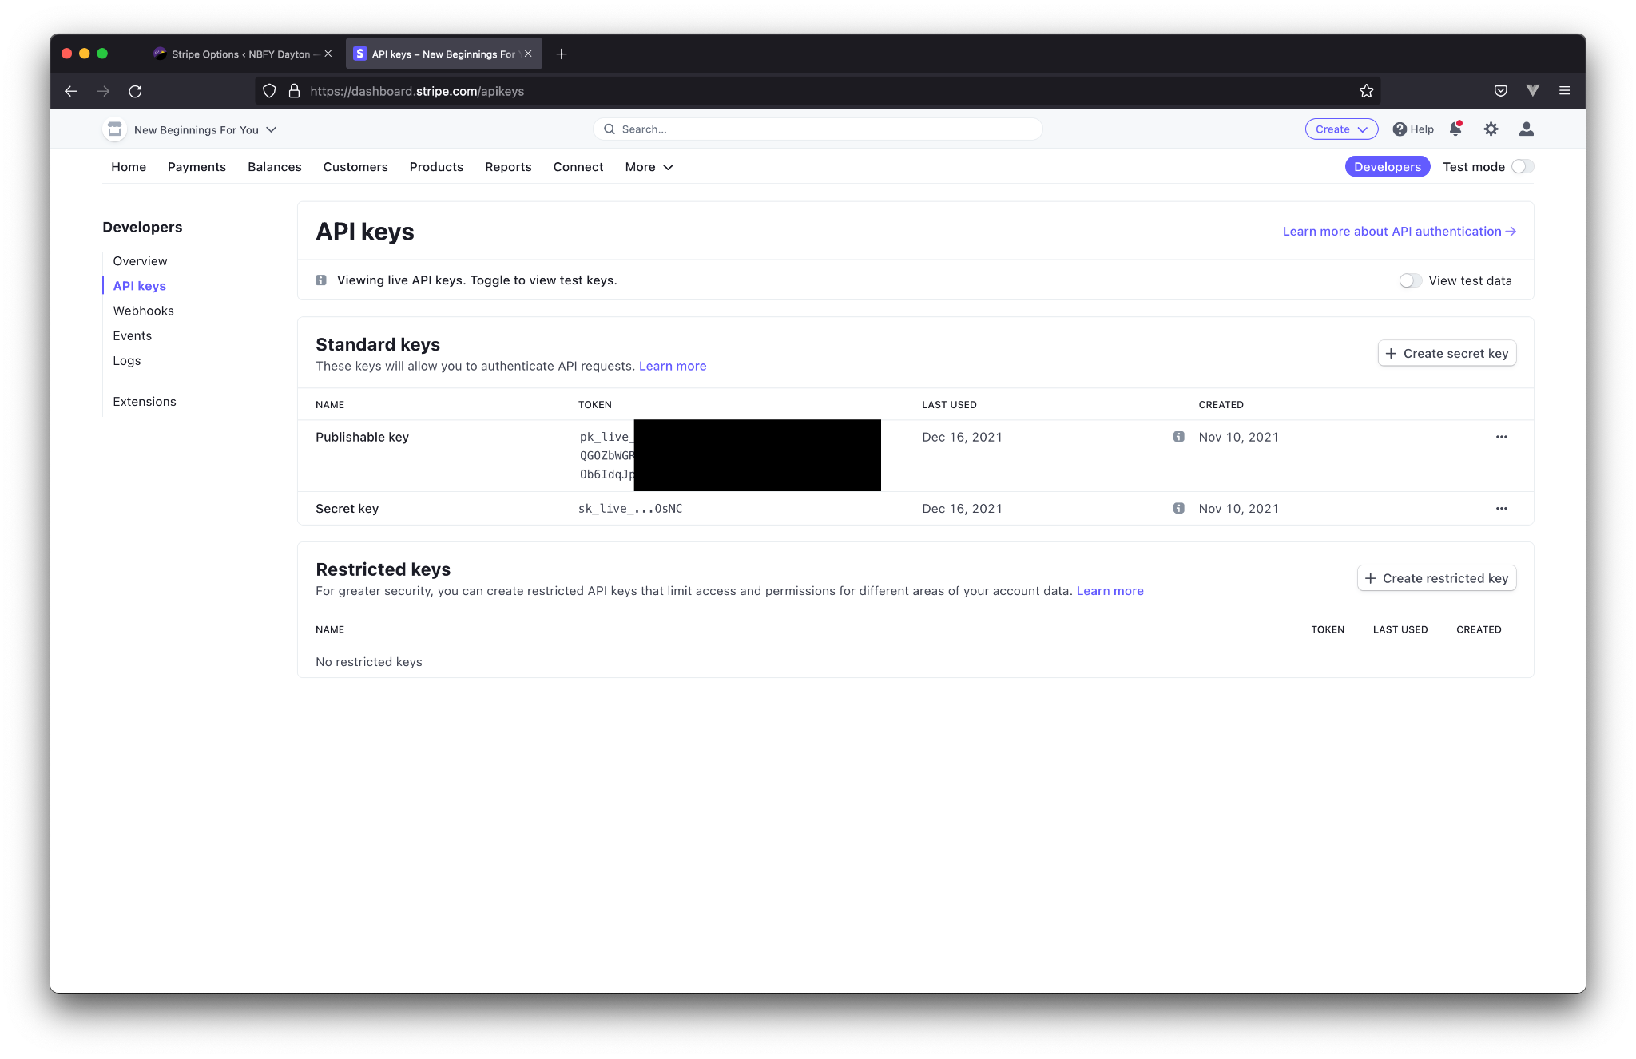

Copy the Publishable key into the “Publishable Live Key” field in the plugin settings.

Copy the Secret key into the “Live Key” field in the plugin settings.

Next, toggle the “Test mode” in the upper right hand corner of Stripe’s website.

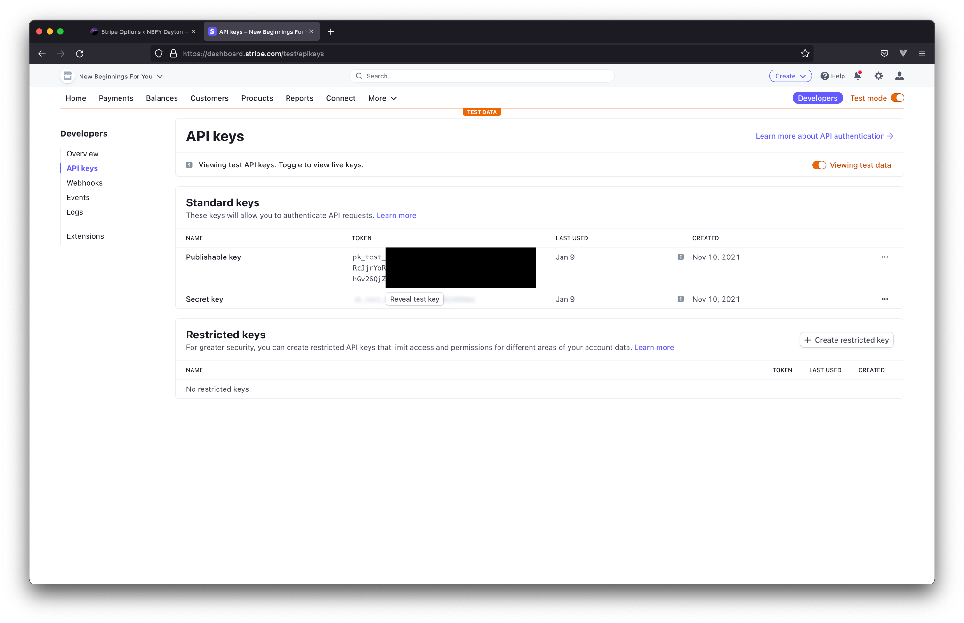

Again, Copy the Publishable key into the “Publishable Test Key” field in the plugin settings.

Copy the Secret key into the “Test Key” field in the plugin settings.

We are done with Stripe’s website. You can close it, and redirect your attention exclusively to the plugin configuration page on your website.

There are two more settings to consider. The first is the “Success Page Slug.” In WordPress terms, a slug is the “example-slug” in “www.example.com/example-slug.” In other words, it is anything after the “/.” This is where you decide what page you want the plugin to redirect to upon a successful payment. In this case, the plugin is set to redirect to “www.example.com/donation-success.”

The last setting toggles “test mode.” When set to test mode, any payments will be sent as a test, and will not be charged to a credit card. Outside of test mode, all payments are live, and will be charged. Make sure you are using test mode if you are making changes to the plugin.

Click “Save Settings” to commit your changes.

The basic settings are complete.

### Creating a page

You may already be familiar with how to create a page in WordPress. If this is the case, you can move on to the next section. Otherwise, please read on.

The following steps describe the standard way to add pages to WordPress. Refer to this section when setting up donation pages if you need assistance.

On our now-familiar sidebar, select “Pages” > “Add New”

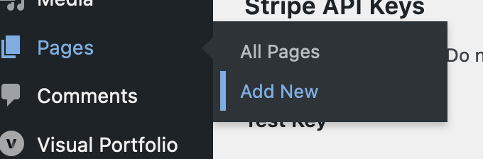

This will take you to a page similar to this:

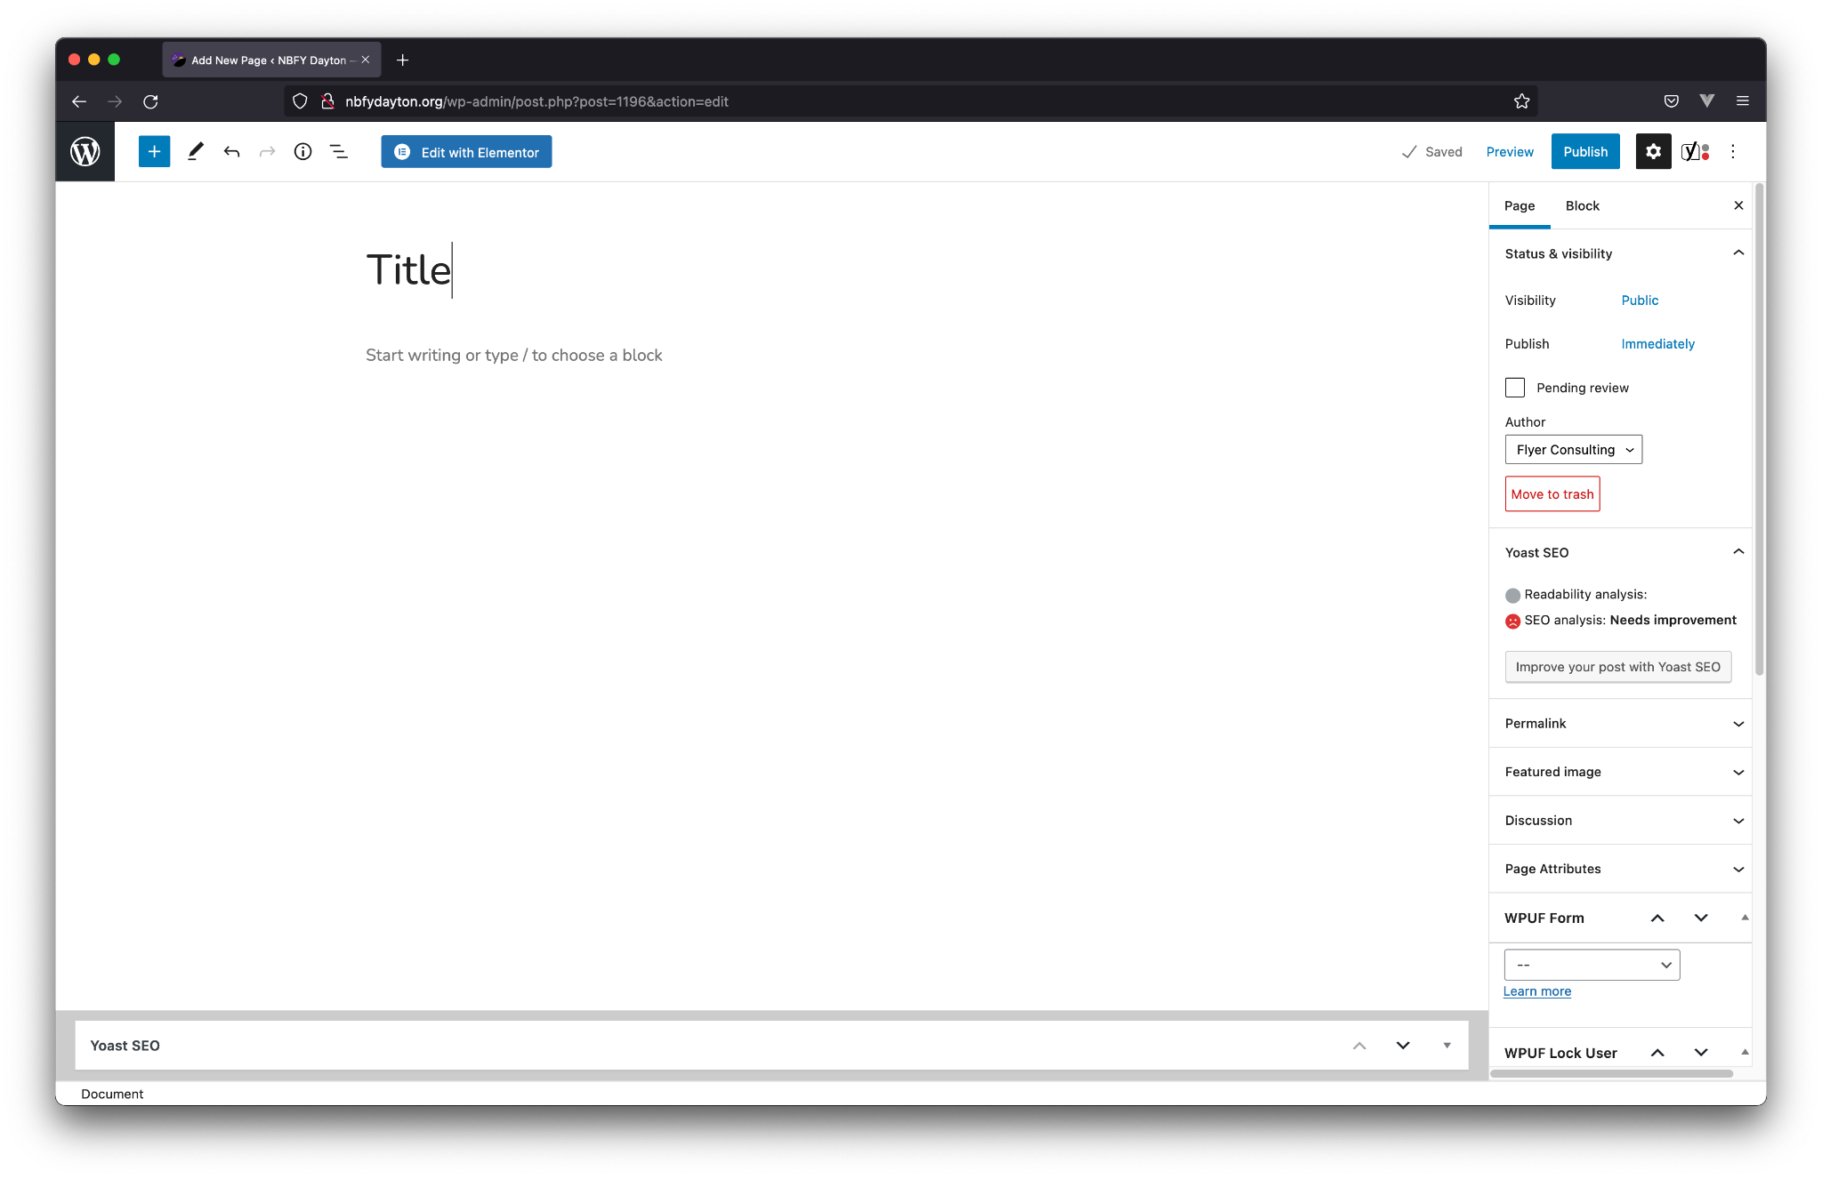

Here is where you can lay out the content of your new page.

The big text at the top is what will become the title of the page. There will not be any text there by default, but if you start typing, you will be editing the title.

On the right hand side, you can configure the “nitty-gritty” of the page. Here is where you will set the “slug” of the page. Again, this is the text after the “/” in the url that refers to your page.

To insert a shortcode, click in the body of the page, and click the plus button. Search for, and select “shortcode.” This will add a shortcode to the page. From here, just type the name of a shortcode - [shortcode_name].

In the upper right hand corner, there are three buttons - “Save draft”, “Preview”, and “Publish.” Save draft saves a copy of the page, but does not publish it for the public to see. Preview allows you to see what the page will actually look like to the end-user. Finally, Publish will make the page available to the website, and allow users to see it. This must be done for the page to be visible.

Let’s move on to the fun stuff.

### Donation Page

The Donation Page is where you will create the interface for making a donation.

First, create a new page, and give it a name. In this example, I simply chose “Donate.”

Nex, give it a memorable slug. I chose “stripe” for this example.

Finally, add a shortcode, and type “[fcs_stripe]” in for the shortcode value.

This is what the editor should look like when you are done:

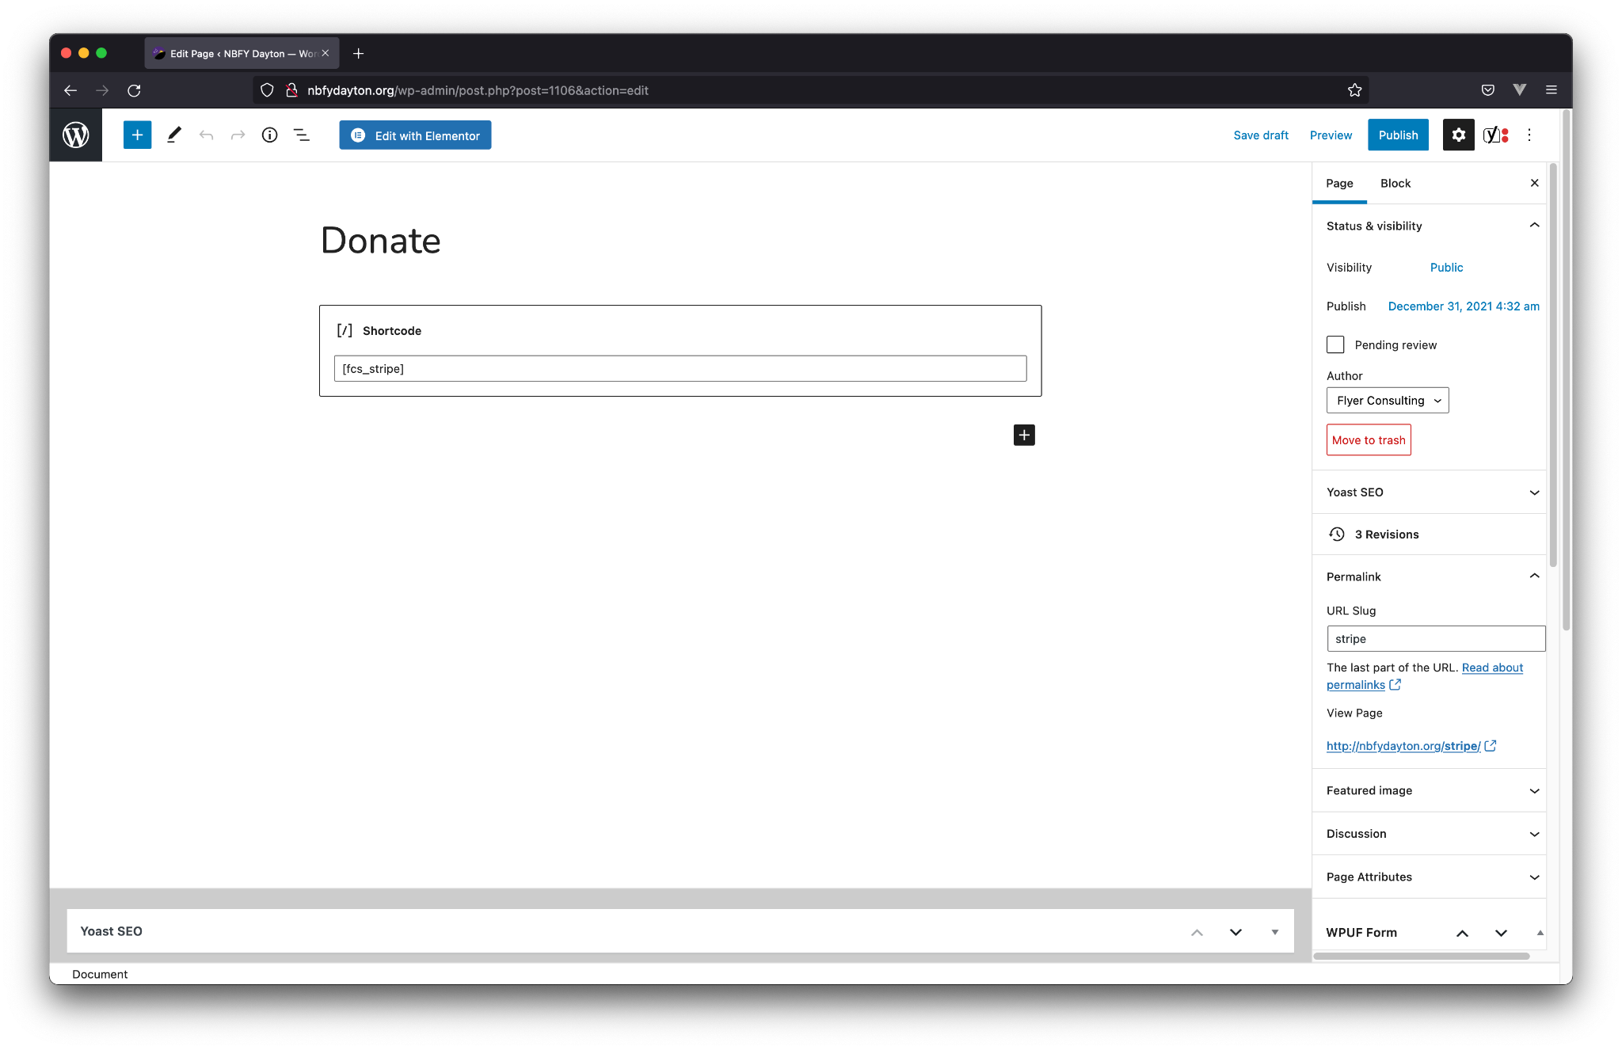

If you wish to include custom content such as text, images, or other items, you may do so. Additionally, if you have an existing page that you would like to add a donation form to, you may simply add a shortcode where you want the form to show up.

### Successful Donation Page

It is important to display a page that shows the user that the donation was successful. Not only is this a great opportunity to thank them, it also gives them reassurance that their payment was successful. Additionally, if the donor chose to make their donation a recurring donation, this is where their subscription id will be displayed to them.

First, create a page and give it a title. In this case, I chose “Donation Success.”

Next, give it a slug. This slug should match the one defined in your settings. If you can’t remember, create a new one, but make sure to update the setting under “FC Stripe” in the sidebar.

Finally, add a shortcode, with [fcs_customer_id].

These are the *required* elements. It is a good idea to include a thank you message as well. The plugin does not include a default message, because Flyer Consulting wanted to provide as much flexibility as possible.

This is an example of what the editor could look like after setup is complete: 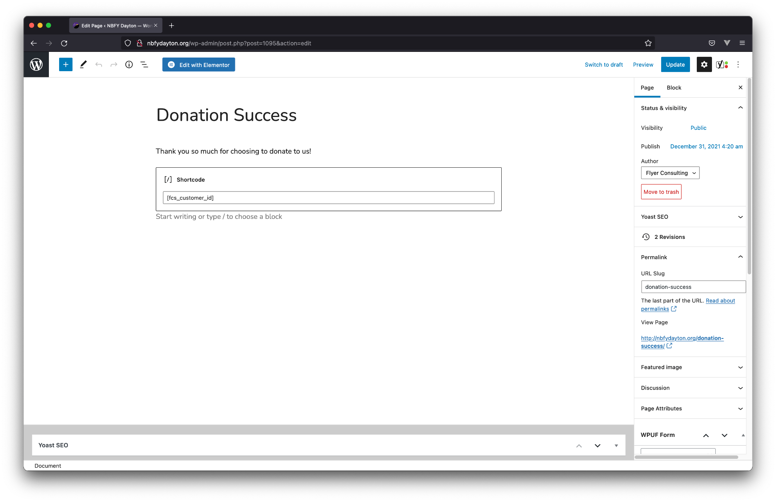

### Cancel Donation Page

Cancelling a donation is important. While this isn’t a strictly required page, it does provide a way for a donor to cancel their subscription without contacting your organization. This is a best practice, and should be done.

First, as usual, we will create a new page and give it a title - “Cancel Future Donations” in this case.

Next, give it a slug. Flyer Consulting chose “cancel-subscription” in this implementation. You will want to link to it somewhere on the website.

As a good practice, add a note to the page thanking the donor for their previous donations. Optionally, provide a link to your contact page so a donor can contact your organization to cancel if the form does not work, or they have lost their subscription id.

Next, add a shortcode, this time with the value “[fcs_cancel_subscription].” This will inject a form that the donor can paste their id into and submit for cancellation.

This is an example of what the editor could look like after configuration: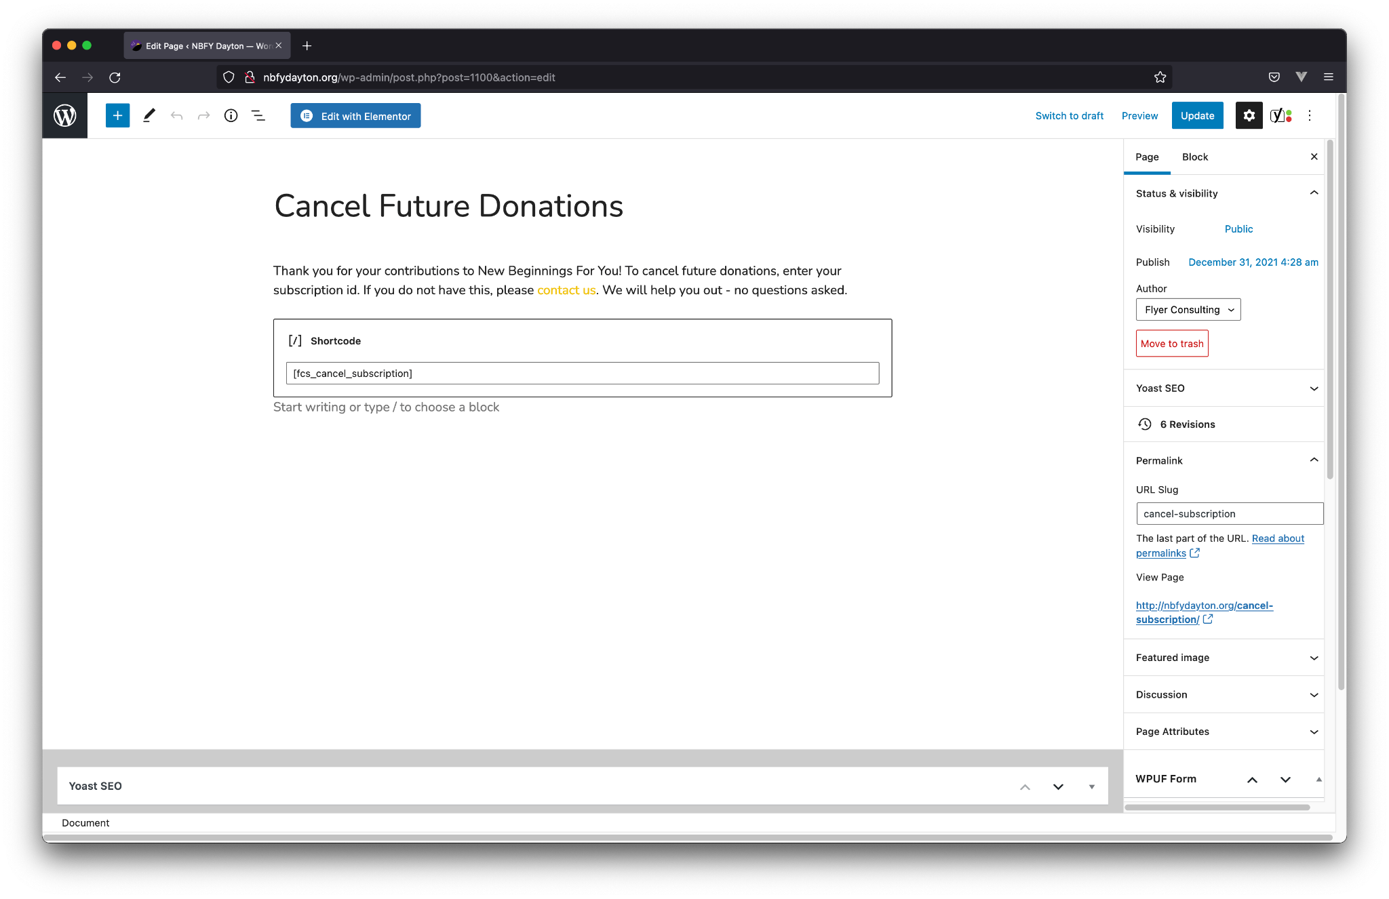

# Conclusion

Thank you for taking the time to read this guide. Flyer Consulting hopes the information provided here will be useful for getting to know your new donation platform. If you have any questions, please contact us at [flyerconsulting@gmail.com](mailto:flyerconsulting@gmail.com), or contact your Managing Director or Project Lead.